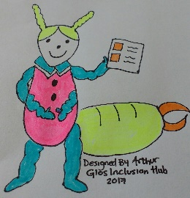
EaRWIG 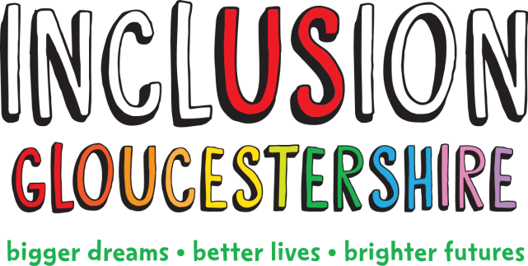
Easy Read with Inclusion Gloucestershire
Inclusion Gloucestershire can help you to make your information

Easy Read
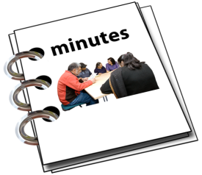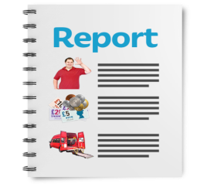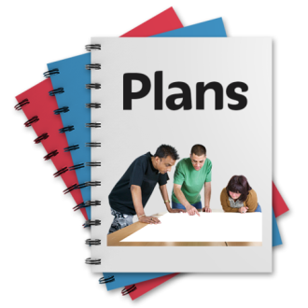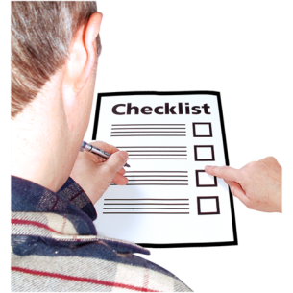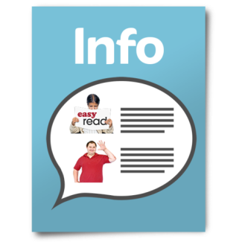 | We can help with all kinds of things like reports or meeting agendas and minutes.  We will make your information easier to understand.  We can use pictures like these or we can use your pictures.  We mostly use photo-symbols pictures for our work.  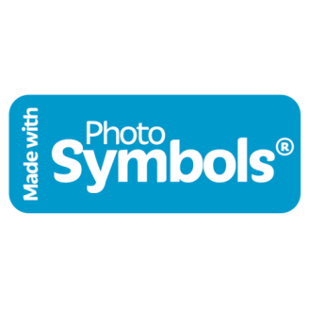
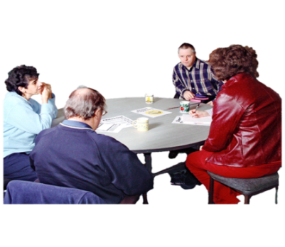 | We have a Reader Panel of people with disabilities.  They will check that the information is easy read before we send it back to you.
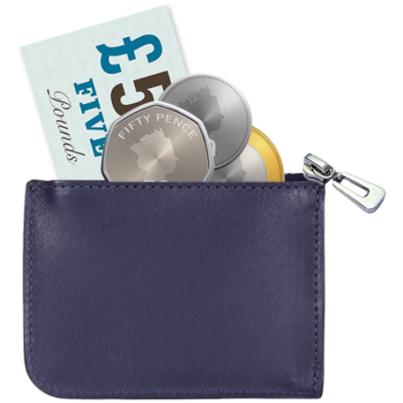  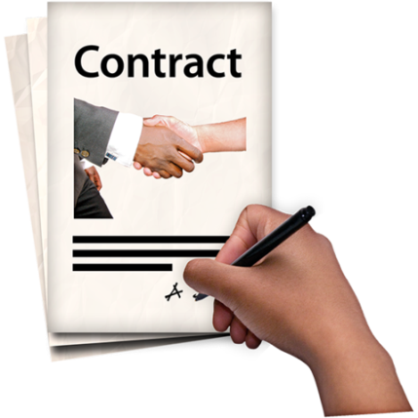 | What does it cost??  We will charge you per word for the number of words in your document that need to be translated.  Our minimum charge for work is £65  We will  - meet with you to talk about what you want and agree the cost  - agree when we will give you the first copy of the work  - check the work with our reader panel  - Send you a document that looks a bit like this one so you can use it how you like.
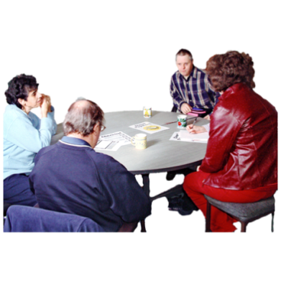  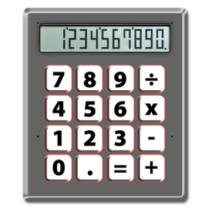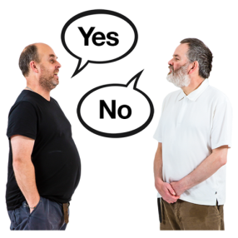 | If you already have information and you would like our reader panel to tell you what they think we can do that too.  We charge £40 per hour for a reader panel.  We would tell you how much it would cost to check your information so you can decide if you want us to do it.
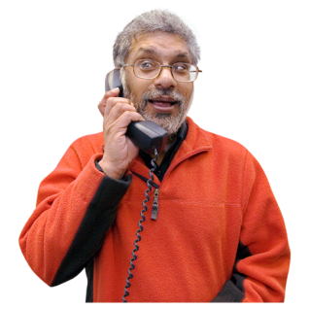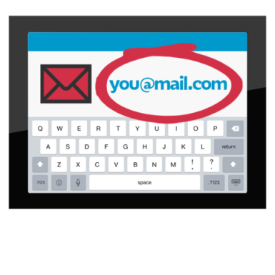 | If you would like more information about our Easy Read work  You can contact us  Andrea Frost  01425 623120  info@inclusion-glos.org

