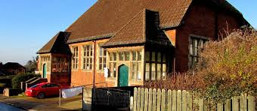
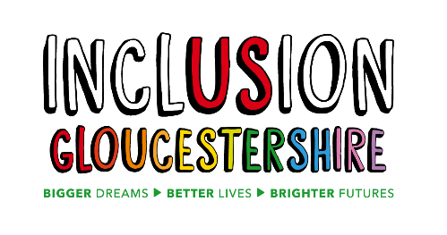
Inclusive Film and Drama Course

The Trinity Rooms, Stroud

15 April– 9 July 2026
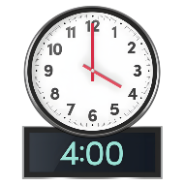
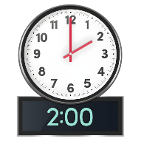
Wednesdays 2 – 4pm (term time only)
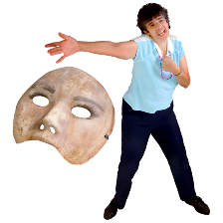
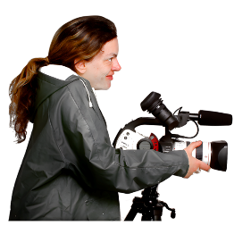
A Film and Drama course where creativity meets social change.

This is an inclusive course, designed for people who face disabling barriers including mental health challenges, neurodiversity, learning or physical disabilities.
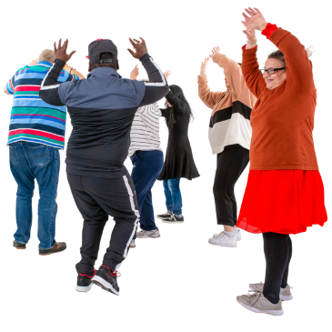
Explore Creative Expression
Using Drama games and exercises you will develop your skills and explore themes that you care about. You’ll discover new ways to communicate, connect, and tell stories.
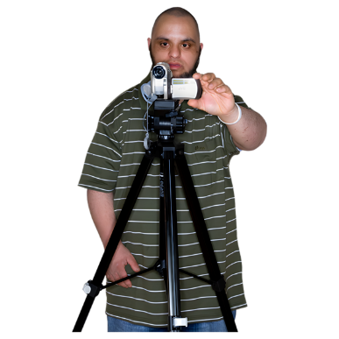
Learn Film-Making Skills
You’ll learn how to transform your stories and performances into film. You’ll get hands-on experience in scriptwriting, directing, filming and acting.

Be Part of a Community for Change
This course is more than learning skills—it’s also about building a community. You’ll have the opportunity to create new friendships, grow your confidence and explore how drama and film can make a difference in the world.

No Experience Necessary
Whether you’ve dreamed of being in front or behind the camera, or are simply curious about trying something new, this course is for you. No prior experience in drama or filmmaking is required—just an open mind and a willingness to explore.

LIGHTS. CAMERA. ACTION!



For more information contact petrap@inclusion-glos.org

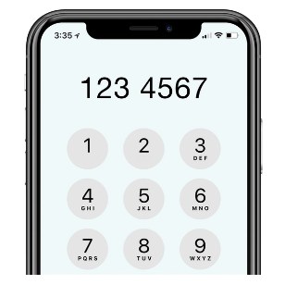
Or

Petra Peters Tel: 01452 234003

