
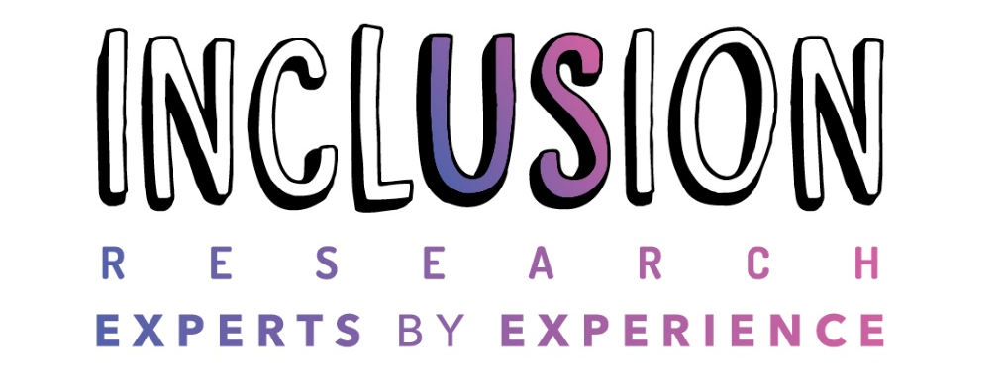

Big Survey 2026

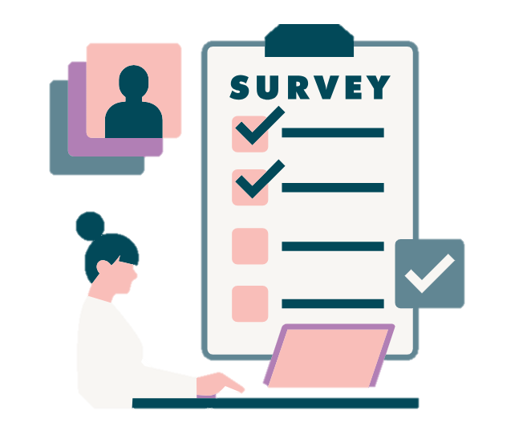

What is the aim of the research?
We are doing this research because we are a Disabled People’s User Led Organisation and we want to find ways to improve the lives of disabled people in Gloucestershire.
We want to find out what the needs and priorities of disabled people in the county are at the moment.
This survey will help us to plan which areas of work we will do that will most improve the lives of disabled people. It will also give us evidence to tell other organisations how they can improve the lives of disabled people in Gloucestershire.
To help us find this out we have created a survey for disabled people to complete.
The results of this study will be made anonymous, analysed and put into a report and video on the Inclusion Gloucestershire website. They will be shared with people who have the power to make changes such as the NHS, Gloucestershire County Council and voluntary sector services.

Who can take part in the research?
You can take part in this research if you are:
• Over 18
• Living in Gloucestershire
• Disabled as per the definition in the Equality Act 2010 that is, you have a physical or mental impairment that has a 'substantial' and 'long-term' negative effect on your ability to do normal daily activities. This will include people who have visual impairments, hearing impairments, learning disabilities, autism, physical impairments, chronic illness, long term health conditions etc. If you are not sure if your condition meets this definition, then get in touch by emailing research@inclusion-glos.org or calling 07517 994765.

Do I have to take part?
You do not have to take part. It is up to you to decide whether to take part or not.
After completion of the survey you can withdraw your data if you have provided your name; but by choosing to be anonymous we are unable to identify your survey in order to delete it. We will no longer be able to remove your data after 30th September.
If you want to take part, you will need to complete the agreement form in the next section.

What will happen if I am interested in taking part?
You can complete this survey online in your own time. If you would like the survey on paper or if you would like to complete it over the phone, please get in touch with Harriet. Her contact information is at the top of the survey.

What might be the benefits to me of taking part?
There is unlikely to be much personal benefit to taking part.
You will be contributing to a study which aims to provide evidence of changes that could improve life for disabled people in Gloucestershire.
What might be the risks to me of taking part?
We do not anticipate or foresee any significant risk to you in taking part in this study. We will take all possible steps to anonymise your data, however, it is possible that someone who knows your situation well may be able to identify you from our report.
If you feel you need help or more information about our survey you can get in touch, and we will try and help.
What will happen to my information?
All of your information will be kept in the strictest confidence. Your details will be kept separate from your survey responses/answers. Any personal or identifying details will be anonymised.
How will you keep my details private?
Your details will be kept separate from your survey responses/answers in a password protected file on a password protected computer, on a drive only able to be accessed by Inclusion Gloucestershire staff.
Data will be stored for 1 year after the survey closes. This will be stored in line with GDPR.
Where will the results be published?
A report will be written with our findings. An Easy Read version of the report will be produced as will an accessible summary video. These will be published on the Inclusion Gloucestershire website www.inclusiongloucestershire.co.uk and via our social media pages. The findings will be shared in meetings across the county with people in positions of influence who can make the changes that the study shows need to be made.
Participants will be asked if they want a copy of the final report at the end of the survey. The report will also be available on the Inclusion Gloucestershire website for people to access if they desire.
What if something goes wrong or I have any questions?
In the first instance, use the contact details for Harriet Roberts above. However, if you wish to pursue the matter further, please contact Debbie Worrall, Research Health and Wellbeing Manager at debbiew@inclusion-glos.org.

Agreeing to take part
I have read and understood the survey information section, or someone has explained it to me and I understand *
Yes
No

I have had the opportunity to ask questions about the research. *
Yes
No

I understand that taking part means I will fill in a survey *
Yes
No

I understand that I do not have to take part, and I can change my mind after I start. I also understand that after I have sent my responses, Inclusion Gloucestershire will not be able to delete them *
Yes
No

I understand that my details will not be shared with anyone outside of the research team unless there are concerns for my safety or the safety of others. Participants have the option to share their contact details with us so they can receive the report directly. *
Yes
No

I understand that if at any point Inclusion Gloucestershire need to break confidentiality due to a safeguarding issue, they will let me know that they need to pass this information on and will follow Inclusion Gloucestershire’s safeguarding policy. *
Yes
No

I understand that my answers may be written in report, video and different types of outputs, and shared with other people, but my name will not be used. *
Yes
No

I allow Inclusion Gloucestershire to safely store my survey feedback electronically so they can use this in more research in the future. I understand that my data will be deleted after a year. *
Yes
No

Eligibility Criteria
Please tell us about your disability. A disability is a 'physical or mental impairment that has a substantial and long-term adverse (negative) effect on your ability to carry out normal day-to-day activities'. If you have more than one disability, please select all that apply.
ADHD
Autism
Chronic illness
Hearing Impairment
Learning Disability
Mental Health Condition
Neurological Condition
Physical Impairment
Sight Impairment
Other
No disability - sorry you cannot complete this survey. Please finish here.

Are you aged 18 or over? *
Yes
No

Do you live in Gloucestershire? *
Yes
Yes - Some of the year I spend in Gloucestershire as a student
No - sorry, you cannot complete this survey. Please finish here.

Health Care
How do you feel about accessing the health care you need? *
😀 I am very satisfied
🙂 I am a little satisfied
😐 I am not sure
🙁 I am dissatisfied
😔 I am very dissatisfied
😶 This does not apply to me
Please give a reason for your answer *

Mental Health
How do you feel about accessing support for your mental health and well-being? *
😀 I am very satisfied
🙂 I am a little satisfied
😐 I am not sure
🙁 I am dissatisfied
😔 I am very dissatisfied
😶 This does not apply to me

Please give a reason for your answer *

Social Care
If you get help from the social care team, how do you feel about your social care assessment or reviews of your support? *If you get help from the social care team, how do you feel about your social care assessment or reviews of your support? *
😀 I am very satisfied
🙂 I am a little satisfied
😐 I am not sure
🙁 I am dissatisfied
😔 I am very dissatisfied
😶 This does not apply to me

How happy are you with the involvement you have with making decisions about you social care?
😀 I am very satisfied
🙂 I am a little satisfied
😐 I am not sure
🙁 I am dissatisfied
😔 I am very dissatisfied
😶 This does not apply to me

How happy are you with how social care supports you to be as healthy and independent as you can be?
😀 I am very satisfied
🙂 I am a little satisfied
😐 I am not sure
🙁 I am dissatisfied
😔 I am very dissatisfied
😶 This does not apply to me

Please give a reason for your answer *

Advocacy
How do you feel about getting access to advocacy support if you feel you need it? *
😀 I am very satisfied
🙂 I am a little satisfied
😐 I am not sure
🙁 I am dissatisfied
😔 I am very dissatisfied
😶 This does not apply to me
Advocacy is speaking up for yourself or asking other people to speak up for you.

Please give a reason for your answer *

How do you feel about sharing concerns, complaints or compliments with any of the organisations who you are supported by? *
😀 I am very satisfied
🙂 I am a little satisfied
😐 I am not sure
🙁 I am dissatisfied
😔 I am very dissatisfied
😶 This does not apply to me

Please give a reason for your answer *

Finances
How do you feel about your finances? *This might include the money you have coming in, bills or debts.

😀 I am very satisfied
🙂 I am a little satisfied
😐 I am not sure
🙁 I am dissatisfied
😔 I am very dissatisfied
😶 This does not apply to me

Please give a reason for your answer *

Housing
How do you feel about your housing? *
😀 I am very satisfied
🙂 I am a little satisfied
😐 I am not sure
🙁 I am dissatisfied
😔 I am very dissatisfied
😶 This does not apply to me

Please give a reason for your answer *

Help to find work
How do you feel about getting support to find or maintain paid work or voluntary work? *
😀 I am very satisfied
🙂 I am a little satisfied
😐 I am not sure
🙁 I am dissatisfied
😔 I am very dissatisfied
😶 This does not apply to me

Please give a reason for your answer *

Leisure
How do you feel about your access to leisure activities? *
😀 I am very satisfied
🙂 I am a little satisfied
😐 I am not sure
🙁 I am dissatisfied
😔 I am very dissatisfied
😶 This does not apply to me

Please give a reason for your answer *

How do you feel about being able to have regular contact with friends, family and other people who are important to you? *
😀 I am very satisfied
🙂 I am a little satisfied
😐 I am not sure
🙁 I am dissatisfied
😔 I am very dissatisfied
😶 This does not apply to me
Please give a reason for your answer *

Sexuality and gender identity
Are you satisfied with the attitudes professionals and services have towards your sexuality or gender identity? *
😀 I am very satisfied
🙂 I am a little satisfied
😐 I am not sure
🙁 I am dissatisfied
😔 I am very dissatisfied
😶 This does not apply to me

Please give a reason for your answer *

Discrimination
Are you worried that you have been discriminated against in the last year? Discrimination is if you are treated differently because of who you are. This may be because you are disabled or because of your sexuality or because of your culture or religion. It may also be because of your age or your gender or because you are pregnant. It may also be because you are married or in a civil partnership. *
😔I am very worried
🙁 I am a little worried
😐 I am not sure
🙂I am not too worried
😀I am not worried
😶 This does not apply to me

Please give a reason for your answer *

Culture/religion
Are you satisfied with the attitudes professionals and services have towards your culture and/or religion? *
😀 I am very satisfied
🙂 I am a little satisfied
😐 I am not sure
🙁 I am dissatisfied
😔 I am very dissatisfied
😶 This does not apply to me

Please give a reason for your answer *

Accessibility
How do you feel about the accessibility of any services and facilities you use (for example councils, GP's, banks, leisure centres, buses etc?) *
😀 I am very satisfied
🙂 I am a little satisfied
😐 I am not sure
🙁 I am dissatisfied
😔 I am very dissatisfied
😶 This does not apply to me

Please give a reason for your answer *

How do you feel about getting any accessible information that you need? This could be information from any organisations or services that you use e.g. councils, GP's, banks, leisure centres, buses etc. *
😀 I am very satisfied
🙂 I am a little satisfied
😐 I am not sure
🙁 I am dissatisfied
😔 I am very dissatisfied
😶 This does not apply to me

Please give a reason for your answer *

Personal safety
How do you feel about your safety when you are not in your home? *
😀 I am very satisfied
🙂 I am a little satisfied
😐 I am not sure
🙁 I am dissatisfied
😔 I am very dissatisfied
😶 This does not apply to me
Please give a reason for your answer *

Anything else?
Is there anything not covered here that is an important concern for you?
Education
Access to exercise
Using technology
Caring responsibilities
Reasonable adjustments / support in work
Other

Concern
What is the one thing that is causing you most concern at this time? Please tell us more about this.

About you
What is your gender identity?
Female
Male
Non-binary
Prefer not to say
Other

Do you identify as trans/transgender?
Yes
No
Prefer not to say

What is your sexual orientation?
Heterosexual
Homosexual (Lesbian/Gay)
Bisexual
Prefer not to say
How old are you?
Under 18
18-24
25-34
35-44
45-54
55-64
65-74
Over 75
Prefer not to say

Is English your first language?
Yes
No
Prefer not to say

Please tell us your ethnicity
Arab
Arab British
Asian or Asian British- Indian
Asian or Asian British- Pakistani
Asian or Asian British- Bangladeshi
Asian or Asian British- Chinese
Asian or Asian British- Any other Asian background
Black or Black British- Caribbean
Black or Black British- African
Black or Black British- Any other Black background
Mixed- White and Black Caribbean
Mixed- White and Black African
Mixed- White and Asian
Any other Mixed background
White British
White Irish
Any other White background
Prefer not to say

Which area of Gloucestershire do you live in?
Cheltenham
Forest of Dean
Gloucester
Stroud
Tewkesbury
The Cotswolds
Prefer not to say

Are you a member of Inclusion Gloucestershire?
Yes
No
Not sure
Prefer not to say

Have you been using any of Inclusion Gloucestershire's services in the last 6 months? This might be the Inclusion hubs, drama group, advocacy support, speak up groups or MHELO (Mental Health Experience Led Opportunities).
Yes
No
Not sure
Prefer not to say

Contact Information
Would you like us to send you a copy of the report when it is completed?
Yes (please fill in your contact details below)
No

Please tell us your full name (Optional)

Please tell us your phone number (Optional)

Please tell us your email address (Optional)

If you want to post your survey back to us, please post your survey by
5pm on 30th September 2026 to us at:

Inclusion Gloucestershire
Railway House
Bruton Way
Gloucester
GL1 1DG
Thank you for helping us with our survey

