Eco Hub Volunteer

About us:
Inclusion Gloucestershire is a respected user-led disabled people’s organisation and registered charity, run by disabled people for disabled people.
Summary of the Role:
The new Eco Hub project involves monthly workshops for people with a learning disability to learn about climate change and climate action. The Eco Hub also involves supporting people to access nature through outdoor activities, such as nature walks.
Role Purpose: To work with the Eco Hub team to support people with a learning disability to access workshops and outdoor activities.
Role Title: Eco Hub Volunteer
Reports to: Eco Hub Project Coordinator

Volunteering commitment
Time commitment: approximately 6 hours per month
(3 hours per monthly workshop / 3 hours per outdoor session)
Days: Thursdays
Time: 10am – 1pm
Workshop Location: Railway House, Bruton Way, Gloucester, GL1 1DG

Main Tasks:
- Support with the set-up and pack-down of activities.
- Provide support to members during workshops and outdoor activities.
- Establish and maintain professional working relationships and boundaries with members of the hub and the staff team.
- Represent and champion the views of Inclusion Gloucestershire at the hub.
- Recognise risk, work safely and report any safeguarding or health and safety concerns immediately.

What we are looking for:
- Genuine interest in working with, and supporting, people with a learning disability.

- Good communication skills and ability to easily build rapport with others.

- Friendly, caring and understanding.

- Honest, reliable and trustworthy.

- Ability to follow instructions but also work on own initiative.

- To adhere to confidentiality when required.

- Genuine interest in climate and environmental issues.

- Ability to travel independently.

What we can offer you:
- All volunteers complete mandatory training including health and safety, safeguarding, and GDPR.

- Regular supervision and contact with the volunteer and project coordinator.

- Reasonable travel expenses will be reimbursed.

- Information about wider development, volunteering and paid work opportunities when these arise.

Next steps:
If you are interested, please complete our application form.
Or contact the Project Coordinator by email: rosannag@inclusion-glos.org
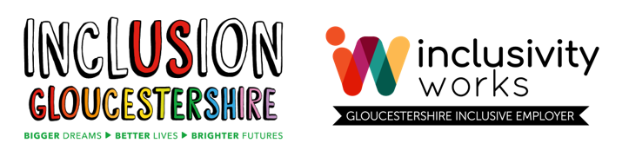
This project is funded by National Lottery funds raised through the proceeds of a lottery.

