Inclusion Gloucestershire’s Involvement in Care and Treatment Reviews

Easy Read

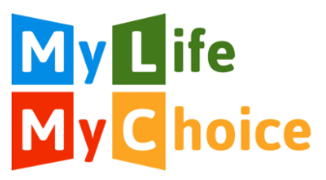 | We understand why My Life My Choice will not be a part of Care and Treatment Reviews any more.  We plan to still be a part of CTR panels. This is because we think they are better when someone who has a learning disability or is autistic is on the panel.  Our Experts by Experience ask questions and challenge when things feel wrong.  Like My Life My Choice, we are worried that the number of people in secure units and hospitals is getting bigger. We are also worried that some people are still getting care and support that isn’t good enough.  CTRs should be making this better, but they are not doing that for enough people.  We think that the whole Transforming Care system needs to change and be better.  We are working with NHS England to check how well different types of advocacy are working for people with a learning disability or who are autistic.  We will keep checking whether it feels right for us to be a part of CTR panels, and if we are making things better.  We will make these decisions with people who are autistic or have a learning disability.

