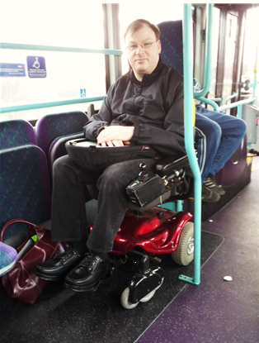
Access
for us
all?

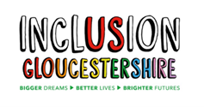
A report and ideas about the things that make it harder for people to get around.
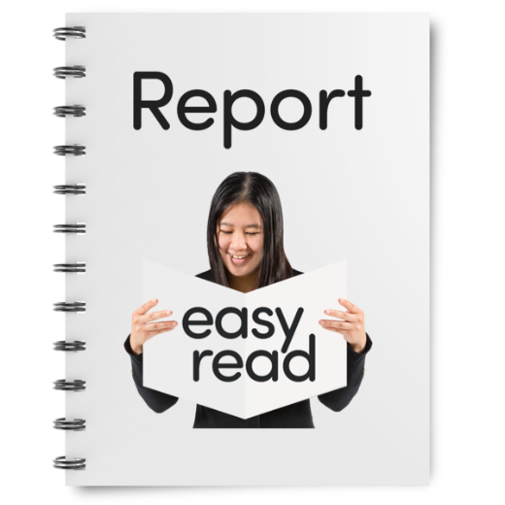

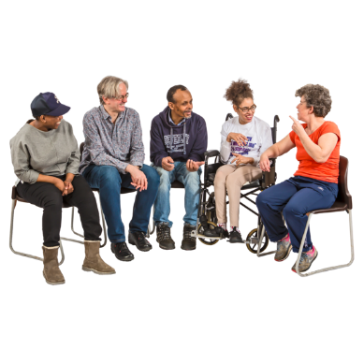
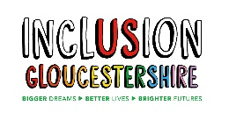
Why we made this report and what we did.
Inclusion Gloucestershire spoke to lots of disabled people about the things that affect their lives.
We did this at places around Gloucestershire, this is called consultation.
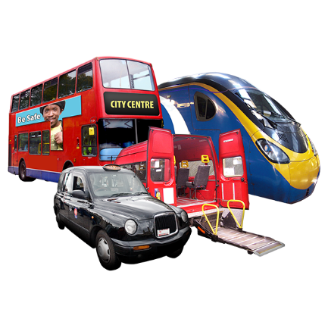

People said one of the main things that is a problem is getting around using things like buses, trains, and taxis. This is usually called public transport.

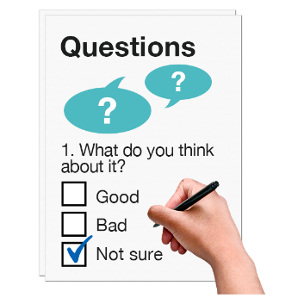
We wrote a survey with people from the transport group, they were, Inclusion Gloucestershire, The University of Gloucestershire and Gloucestershire County Councils, SEN Travel Enablement Team.
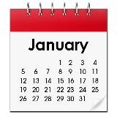
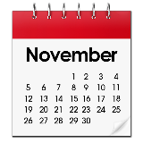

The survey was from November 2020 to January 2021.
We had some help from The Digital Innovation Fund (DIF) to work on some ideas we had for making things better.
One idea was to have an app to tell people if there was a space, like a wheelchair space on a bus or a taxi that has a space for a wheelchair, at that time.
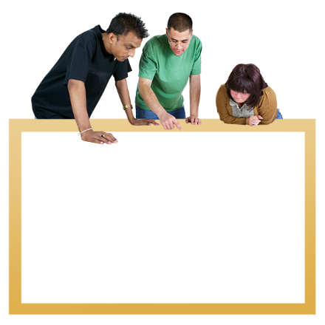
Another idea was to ask university students to make a model of a bus that would be good for people with disabilities.
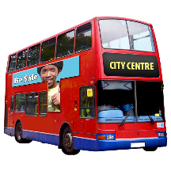
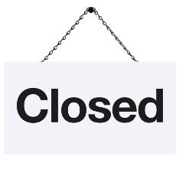
Because of Covid-19 we have no been able to do things as quickly as we wanted.

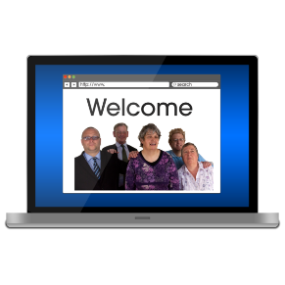
About the survey.
Our survey called Barriers to Mobility was on the Gloucestershire County Council website.

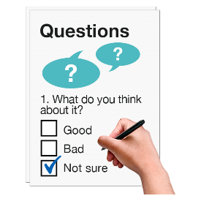
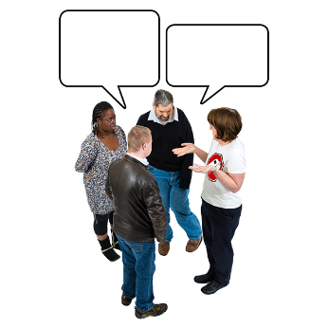
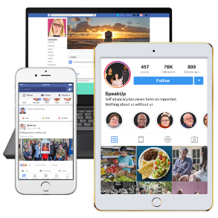
We had and easy read survey for people if they needed it.

We made sure lots of other groups knew about the survey so they could tell people about it.

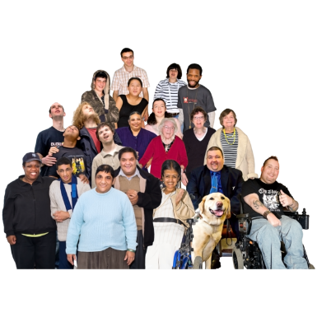
We told people about it on social media like Facebook, Instagram and Twitter.
150

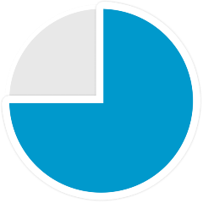
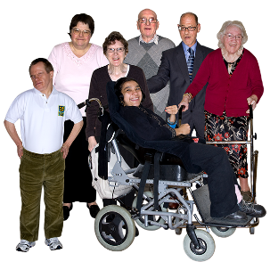
What we found out.
150 people filled in the survey.
Nearly ¾ of people were over 50 years old.
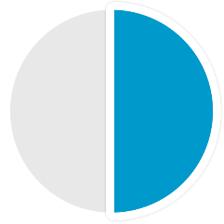
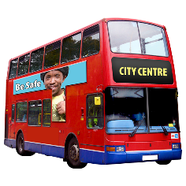
Most people said they had a physical disability or problems getting around because they are older.

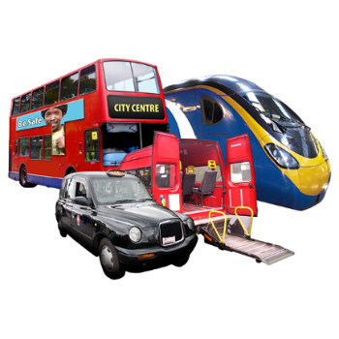
We asked people about which public transport they use.
Over ½ the people said they use buses.
A lot of people said they do not use public transport at all because it is no good at meeting their needs.
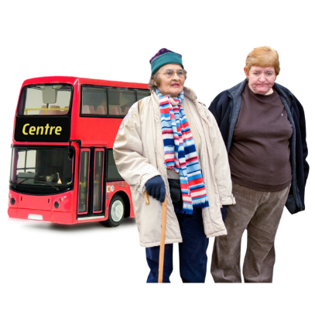
Most people said they had not used a bus for over a month but this might have been because of Covid-19.

We asked people why they use public transport.
Most people use it to go shopping or see friends.

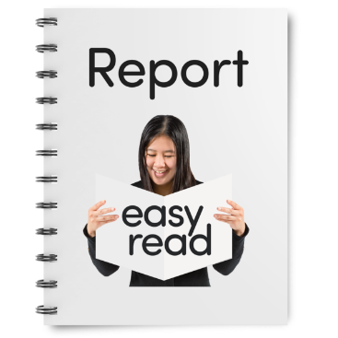
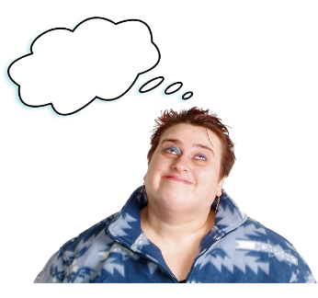
The main things we found out.
4 Things
We found 4 main things that make it harder for people to get around.
- The way staff on public transport support people with disabilities.
- Being able to go bike riding and cycle paths.
- Things like pavements, bus stops and crossing places.
- Planning a journey and being able to go out at short notice.
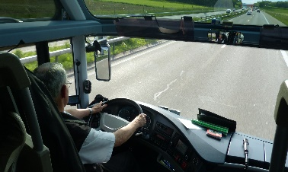
What we found out about the way staff on public transport support people with disabilities.

The way people like bus drivers, train station staff and taxi drivers are towards people with disabilities makes a big difference to how people feel about using public transport.
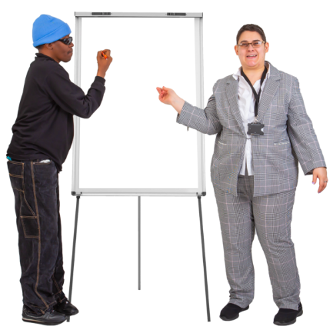
If staff are not friendly and helpful people feel they do not want to use public transport.

Lots of people said they thought bus drivers need more training about how to help people with disabilities.
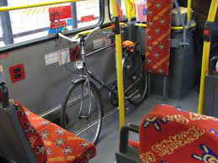
Some people said bus drivers don’t always understand why it important that someone who uses a wheelchair can use the wheelchair space on a bus.

The wheelchair space is often taken by someone who does not need it or by pushchairs or shopping.

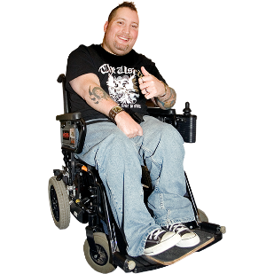
Everybody should be able to use public transport.

What we found out about being able to go bike riding and cycle paths.
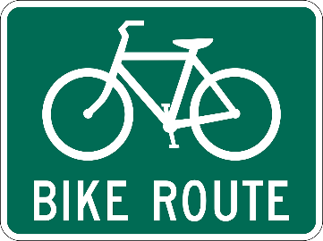
People said that cycle tracks are not planned well.
They said they are not looked after.
This makes it difficult for people to use them and feel safe.
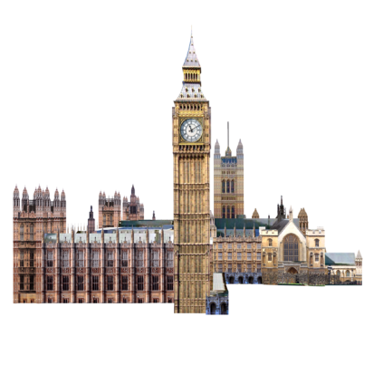
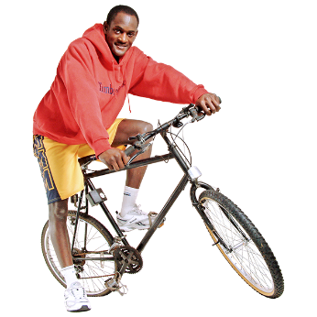

The Government want more people to use their bikes to get around.
People said this would not happen if the cycle paths were not better looked after.
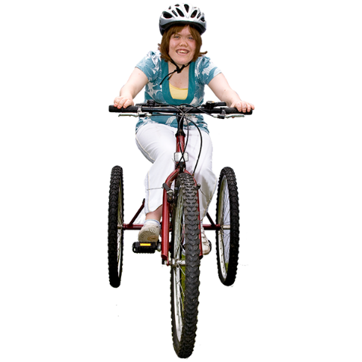

People with disabilities want to be able to ride bikes.
There are only two places in Gloucestershire they can ride bikes that meet their needs.
These are called accessible bikes.

We think that if people could use accessible bikes in more places, they could get the skills and confidence to ride bikes more.
Cycle paths are mostly no good if people want to ride an accessible bike.

Everybody should be able to ride a bike if they want to.
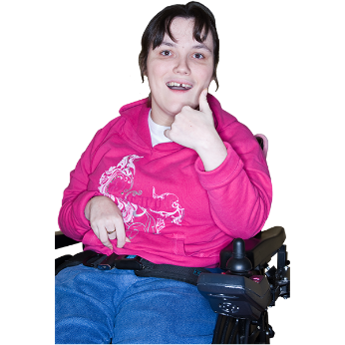

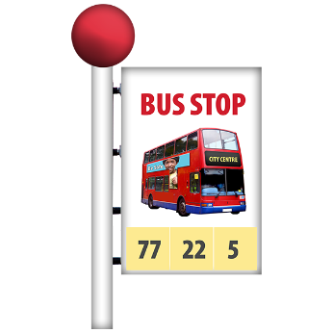
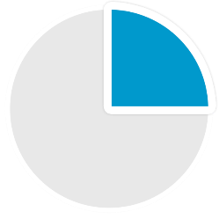
What we found out about things like pavements, bus stops and crossing places.

Only ¼ of people said they thought bus stops were well looked after.
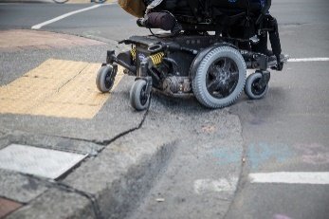
Lots of people said they have problems with curbs and pavements.
It is a problem when people park their cars on the pavement because people who use wheelchairs can’t get past.
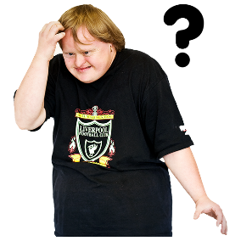
It can be dangerous if someone who uses a wheelchair has to go into the road to get past a parked car.

Some people told us that bus stops can be confusing especially for people with learning disabilities.
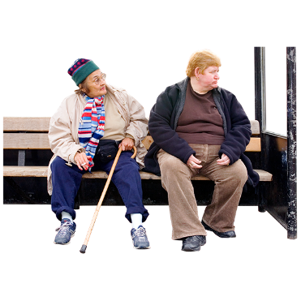
Some bus stops have shelter but some only have a sign.

It can make some people anxious when buses do not come or come at different times.
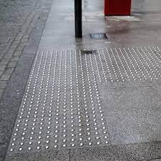
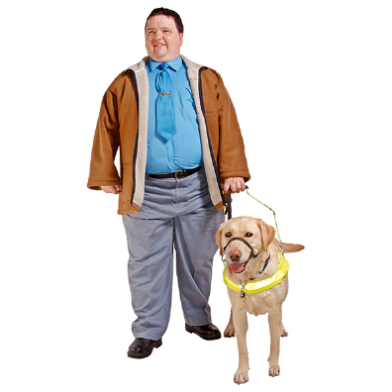
Some people who use wheelchairs said the bumpy pavement, called Tactile Paving which helps people who cannot see, is uncomfortable and difficult for them to use.

Tactile paving is really important for people who cannot see.

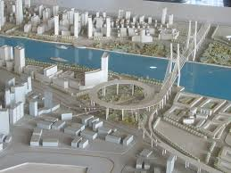
From what people said, it seems like work should be done to make towns better for everyone to use.

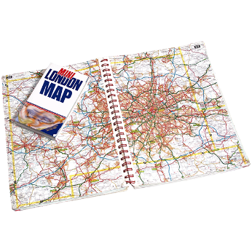
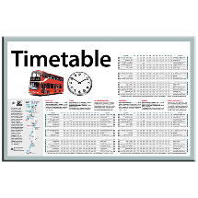
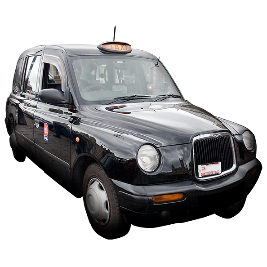
What we found out about planning a journey and being able to go out at short notice.

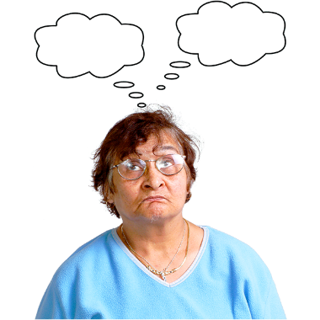
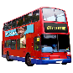
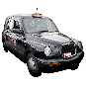
People with disabilities might have to make a plan if they want to go out.
It can be hard to go out whenever they feel like it.
Just under half the people who answered our survey said that not being able to rely on a bus coming would make them choose another way to travel.
A quarter of people who use wheelchairs said they would go home if there wasn’t a wheelchair space on the bus.
This can mean people do not get out and meet other people or they miss things like appointments.
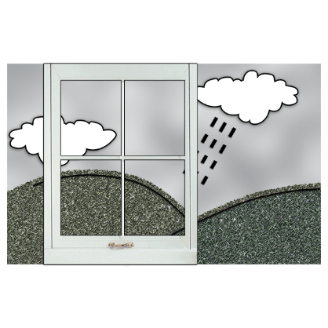
Getting on and off the bus can be difficult and embarrassing.

The weather can be a big problem for people with disabilities getting around and can stop them going out.

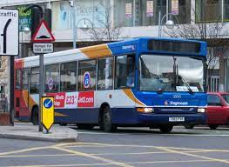
It is important that people have information about when public transport will come and if there will be a space for them.

Things like the Stagecoach App can be very helpful.

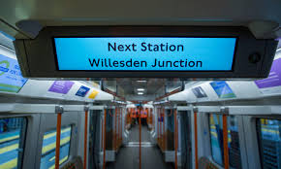
People said it would be helpful if buses could have information like on trains about the next stop.

We think people should be able to get the information they need about public transport in a way that is helpful to them.
People should be able to use technology like an App to see up to date information about things like bus times.
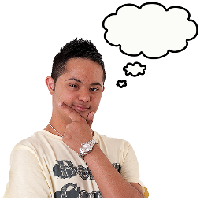
Our ideas about what needs to happen to make things better.
The way staff on public transport support people with disabilities.
People who answered our survey said that sometimes staff on public transport like buses and trains don’t understand about disabilities.
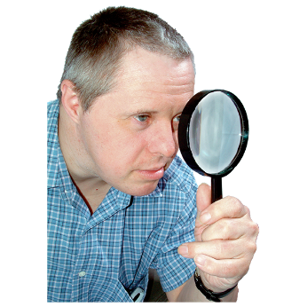
We think there should be a check on the training transport staff have about disabilities.

We think people with disabilities and the organisations that support them should be able to help decide what should be in the training.

Being able to go bike riding and cycle paths.
At the moment there are only 2 places people with disabilities can ride bikes that are specially made for people with lots of different needs.
These are Gloucester and The Forest of Dean.
We think it would be good if there were more places people could try bike riding.
We think people might feel more confident using cycle paths in other places after trying it out.
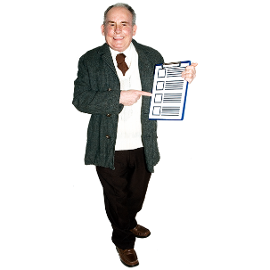
We think that some cycle paths are not easy to get to and are not in a good state.
We would like people who can make decisions about cycle paths to think about making a report about what cycle paths are like and saying how they can make them better.

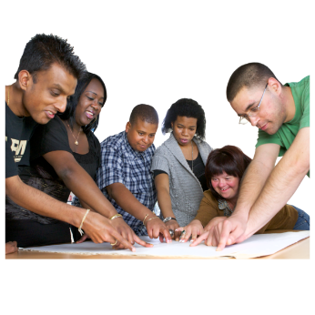
We would like the Physical Disability and Sensory Impairment Board to be involved in planning the new cycle path between Cheltenham and Gloucester so they can say what would help make it good for people with disabilities.
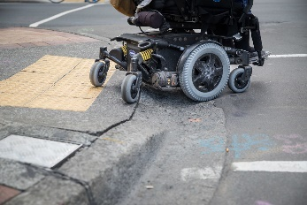
Things like pavements, bus stops and crossing places.
We suggest that there is a way for people to tell the council about bad and blocked pavements and curbs.
We think it would be good if they looked at how people could tell them online, this could be using something called ‘Common Place’.

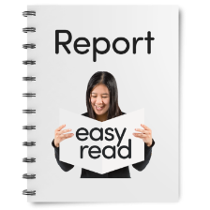
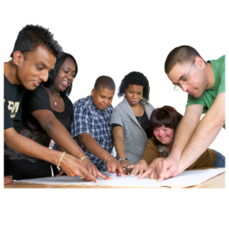
It would be good if there was a report made about bus stops so it can show which bus stops are not easy for people with disabilities to use.

We suggest that when new bus stops are planned people with disabilities can be involved in making sure they are easy to use.
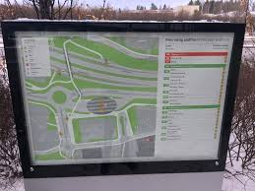
Our report found that it would be good to have more places people can get information about bus and train times.
The information needs to be easy for people to find and understand.
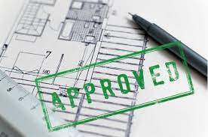
We think people with disabilities should be asked about things like curbs and crossings and bus stops when new houses are being planned.

Planning a journey and being able to go out at short notice.
People might need to plan ahead if they want to go out, this means it is more difficult for them to decide to go out at short notice.

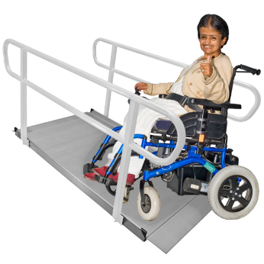
We think it would help people plan if there was a way different places and transport could say more clearly about how easy it is for people with different needs to use them.

We think it would help people plan if they could easily find out when taxis with ramps and wheelchair spaces are available.

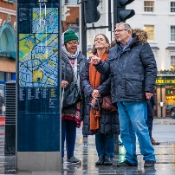
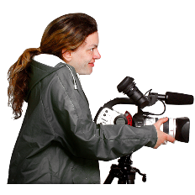
It would be good to help the public understand better about disability and getting around.

We think one way of doing this would be to make some films about the things that make getting around more difficult for people with disabilities.

