

 | We are looking for trustees to help make big decisions for out charity
         | Trustees come to meetings every 2 months.  These are on a Wednesday, 5:30pm to 7:30pm.
 | Trustees read or watch information that we share before the meeting.  These can be in Easy Read or video.
 | Trustees talk about important things in meetings and make decisions.
 | Meetings can be in person at our Gloucester office or online by video call
 | Trustees may help with other jobs like marketing or managing our money
 | Trustees are volunteers. They are not paid.  We pay for travel costs to come to meetings
 | Trustees need to give about 3 or 4 hours time a month
 | Trustees must be over 18
 | Trustees cannot work for Inclusion Gloucestershire, either now or in the last year.
 | Trustees need to:  • Listen and talk well  • Be patient and kind  • Be proud of your work  • Work well in a team  • Want to help Inclusion Gloucestershire  • Believe in what we do
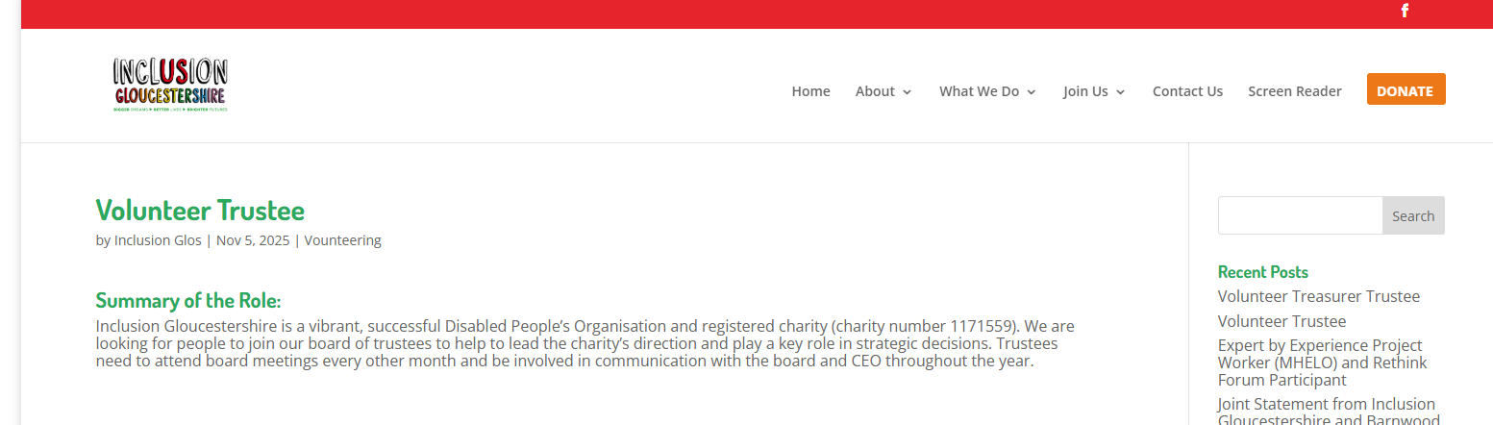 | The application form is on our website: https://www.inclusiongloucestershire.co.uk/volunteer-trustee/
   | If you want help to apply for the job, please call us on:  01452 234003 or  email: info@inclusion-glos.org
   | You need to tell us you are interested in the job by the 30th November
 | There will be an interview online in the second week of December  We will try to make it friendly and relaxed
 | You can tell us what will make the interview work best for you.
 | New trustees will join the board at our AGM on 4th February 2026

