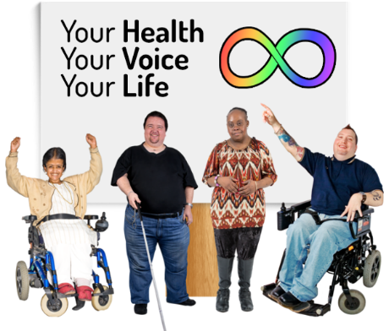

Our Report
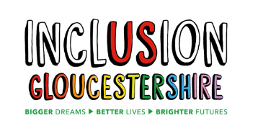
We are Inclusion Gloucestershire.
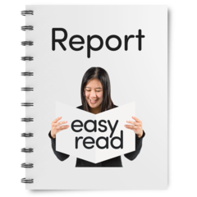
We have made this report about our health work.
The project is called “Your Health, Your Voice, Your Life”.
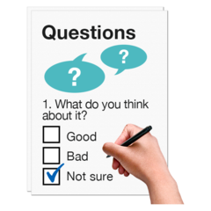

We asked autistic people and people with learning disabilities questions. Some family and friends answered questions too.
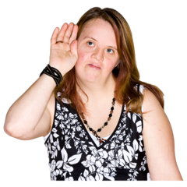
We wanted to listen to what people say about health. We want to make health better.

This report is about the health work and what people told us.

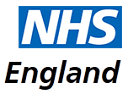
NHS England asked us to do this work.

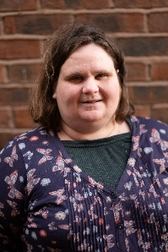
The people who worked on the project are:
Sammy Roberts. Sammy is autistic and has lots of experience of working in self advocacy.

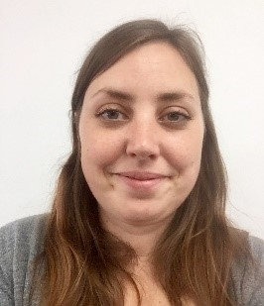
Rosie Mockford. Rosie is a Learning Disabilities Nurse. Some of her family have autism and learning disabilities.

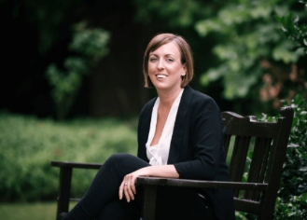
Vicci Livingstone-Thompson. Vicci is the Chief Executive Officer of Inclusion Gloucestershire and an Expert by Experience.

What we did
We asked people questions about health.

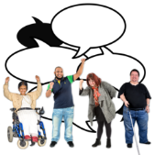
We asked people questions about user led groups.
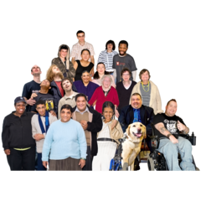
230

We sent this to more than 230 people and groups.
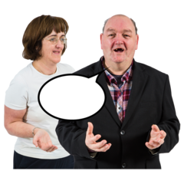
118

118 people replied. They told us a lot!

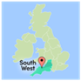
We did lots of research about other user led groups in the South West.

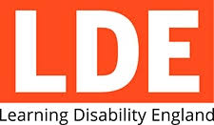
We also worked with people like Learning Disability England and other groups run by people with disabilities in the South West of England.
What we found out
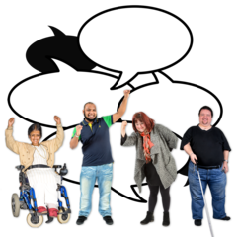
We found out that there are user led groups doing lots of important work.

Some user led groups stopped because the funding had stopped.
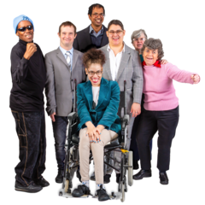

Some were smaller groups of people trying to make a difference.

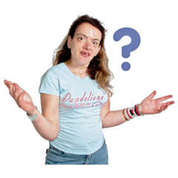
Lots of people said they are not in a user led group. Lots of them want to be, but don’t know how to find them.

Most people said they want to learn about health. People have things to say to the NHS.
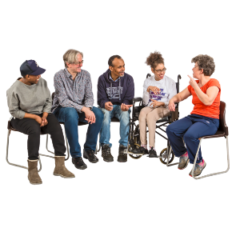
What people want

People in the South West want user led health groups.
Some people found the survey difficult and confusing. It had too many questions.

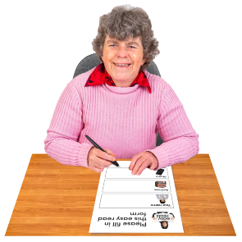
Some people liked the survey because they didn’t need to meet people. Some people could tell us more by doing it on their own.
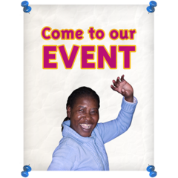
Some people want to meet up and have events to talk and learn about health.

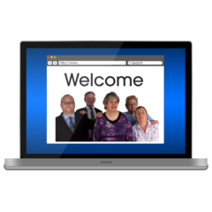
Some people want to use the internet to be involved.
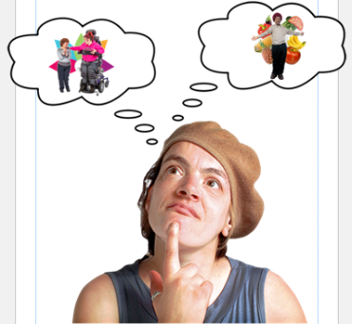
People said they want to learn about things like: dentists and teeth, being healthy, emotions, reasonable adjustments and their rights.

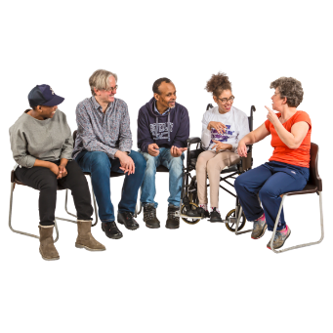
What should we do?

We should start Health Groups in the South West.

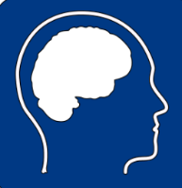
Some people want groups for everyone. Some people want groups just for people with learning disabilities or just for autistic people.

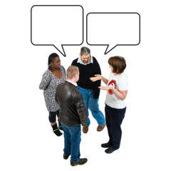
We should talk to people that want to be part of the groups so they can choose how they run.

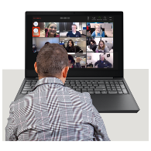
We should have events so people can meet.
We should use the internet and videos for people who can’t come to meetings.
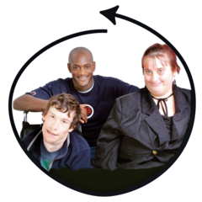

We should work hard to include everyone.

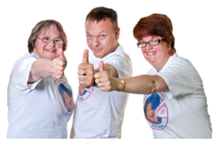
We want to help self-advocacy about health get stronger in the South West.

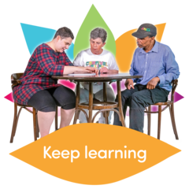

We should make sure people can learn from and talk to the NHS to make things better.

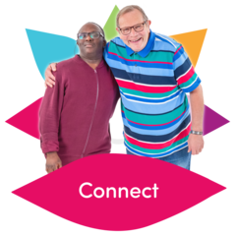

We should work with other people and user led organisations to do this. We can learn from them and share health work we do.

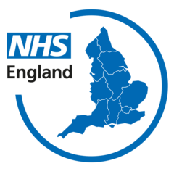

We should work with the NHS because they want to help.

Last words
We know people are worried about Coronavirus. We have a website with more information about keeping safe – https://www.inclusiongloucestershire.co.uk/covid-19/

You can also find out more about Your Health, Your Voice, Your Life on our website.

