

Health Research Project Worker
Job Description

What is the job?
 | In this job you will work with staff at Inclusion Gloucestershire and the Applied Research Collaborative or ARC West.
 | ARC West does health and social care research to find out how to make people’s care and support better.
     | Inclusion Gloucestershire are working with ARC West to help researchers make their research accessible to disabled people.
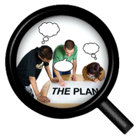 | This job involves finding out what issues are important to people with a learning disability and telling the researchers.
 | You will also share accessible information about research with people with a learning disability.

Who will support me?
 | You will work with the Health Research Coordinator.

What are the main duties in the job?
 | You will have training and support to do this job.
 | Tell ARC West researchers how to work well with people with a learning disability.
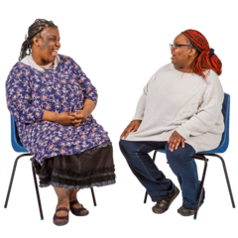 | Tell ARC West researchers how to include people with a learning disability in research.
 | Find out what issues are important to people with a learning disability and tell researchers.
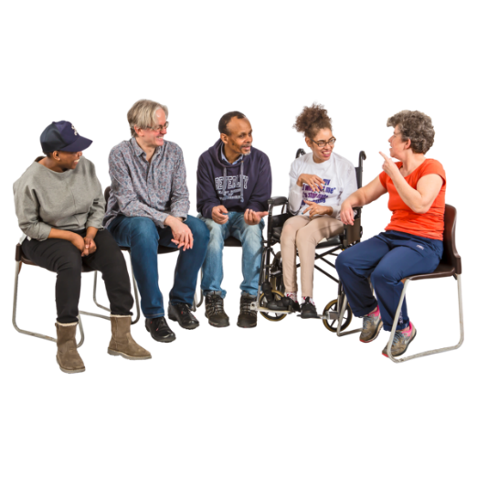 | Tell people with a learning disability about research they could take part in and what has been found out from research.
 | Help with events that will bring researchers and people with a learning disability together.
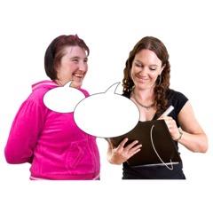 | Sometimes we might ask you to do other things.  This might be going to a meeting, helping to give a presentation or something else.

What do you need to be able to do?

We will choose who to interview based on how well they tell us they can do the skills marked with a tick on their application form.
 | Understand what research is.
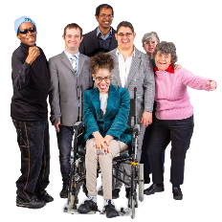 | Have a good understanding of what it is like to be a person with a learning disability.
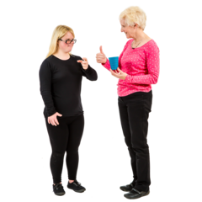 | Have good communication skills and confidence to talk to different people like researchers or health and social care workers.
 | Be interested in improving health and care for people with a learning disability.
 | Have good connections with people with learning disabilities in Gloucestershire and be willing to meet new people.
 | Be willing to help organise events that people with learning disabilities can come to.
 | Be able to use the computer to join online meetings and record your ideas.
 | Work well with others
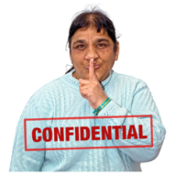 | Keep our work confidential.  This means not talking about the people we meet with anyone outside of ARC West or Inclusion Gloucestershire.
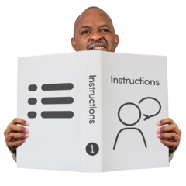 | Follow instructions
 | Be willing to learn new things
 | Friendly, caring and understanding
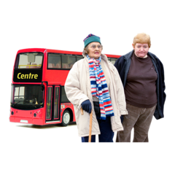 | Be able to travel to different parts of Gloucestershire and to Bristol.
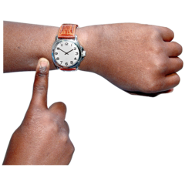 | Be on time, and turn up when you say you will.

Things that would be good to know about already
 | Have experience of doing research
 | Know where you can speak to people with learning disabilities in Gloucestershire.

Inclusion Gloucestershire believes that all staff should

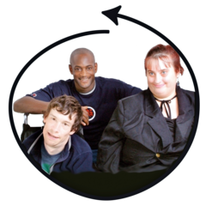 | Make sure everyone is included
 | Make sure experts by experience have choice and control at work
 | Stand up for disabled people when things aren’t right
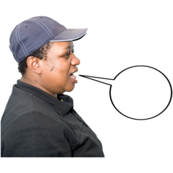 | Be fair and honest all the time
 | Be caring and professional
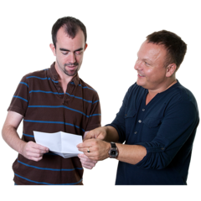 | Support each other to do exciting new things

