INCLUSION GLOUCESTERSHIRE, RAILWAY HOUSE, BRUTON WAY, GLOUCESTER, GL1 1DG
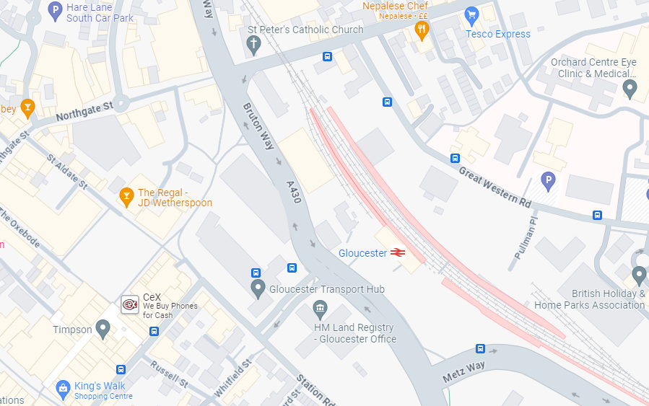
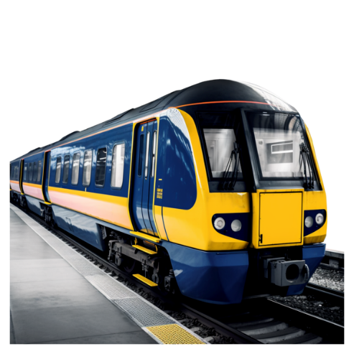
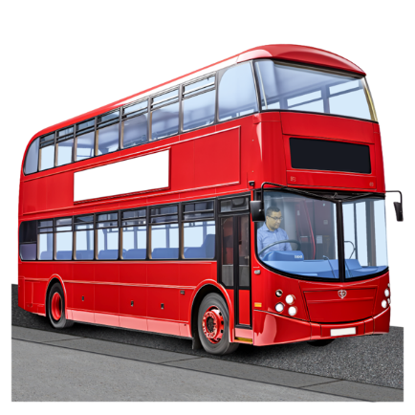
TELEPHONE NUMBER: 01452 234003
Gloucester Train Station

Gloucester Bus Station

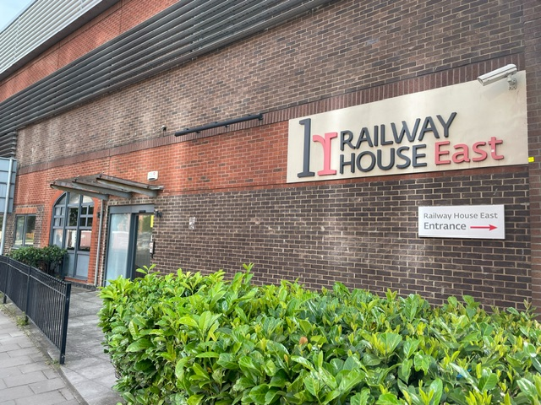
Our entrance looks like this (it is opposite the bus station, it is not the entrance through gates):

Press our buzzer and we will let you in:
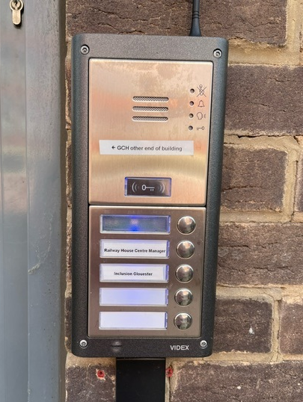

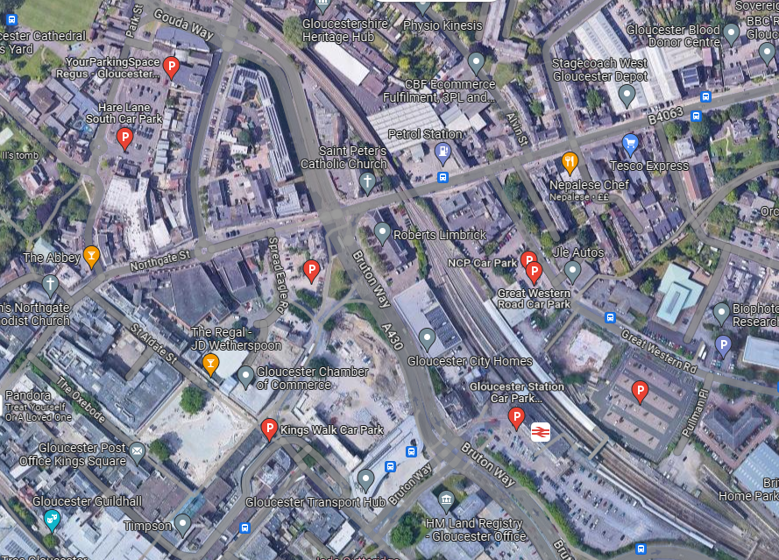
On this map:
This is our office, Railway House
This is the train station
This is the transport hub (bus station)
This is Kings Walk car park
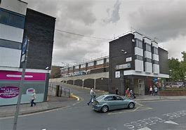
If you are driving to the office there is parking at King’s Walk Car Park, Hare Lane Car Park or Asda Car Park. Asda car park is free for 2.5 hours for customers. The nearest blue badge parking is at the train station – this is free but you must register using the machine or the APCOA app.
If you get lost, please do phone us, our telephone number is 01452 234003
Facilities at the office:
Someone will come and meet you at the door if you are a visitor.
Staff have fobs to get into different parts of the building
Currently doors are not automatic. Someone accompanying you will open doors. We are working with Railway House around accessibility
There are ramps inside the building and our office is on the ground floor.
There are accessible toilets
The nearest Changing Places facility is at Gloucestershire Royal Hospital (a 5 minute walk)

