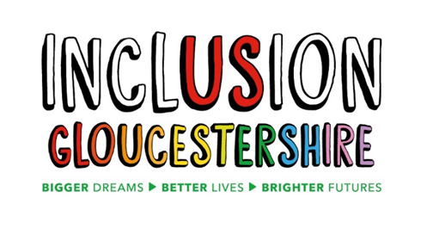

Big Survey 2026
Easy Read

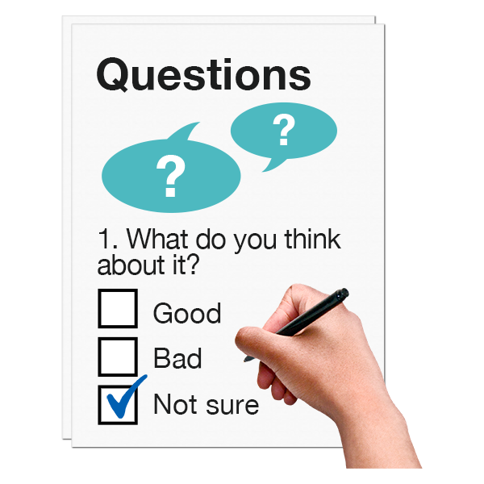

Survey of Disabled People in Gloucestershire 2026
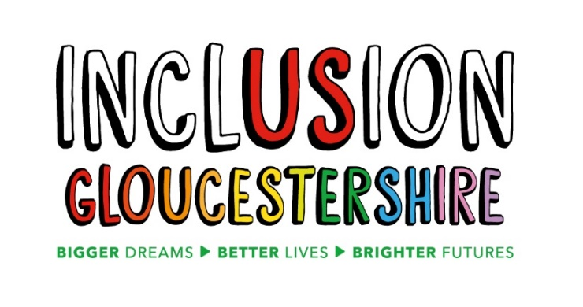


Why are we doing this research?
We are doing it because we want to find ways to make things better for disabled people in Gloucestershire.
We want to find out what people’s needs are in Gloucestershire right now.

Who can take part in the research?
You can take part in this research if you are:
• Over 18
• Living in Gloucestershire
• Disabled.

Do I have to take part?
You do not have to take part; it is up to you.
You can stop taking part even if you have agreed to take part.

What will happen if I am interested in taking part?
You will need to sign the next part of the survey to say you agree to take part.
You will need to fill out the survey.
We can help you fill this out if you want us to.



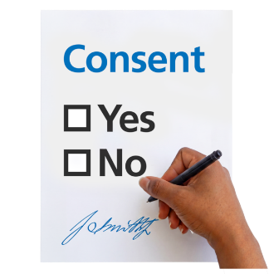

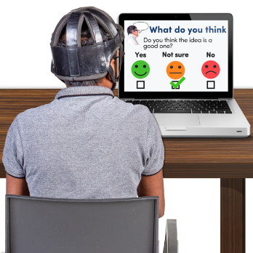

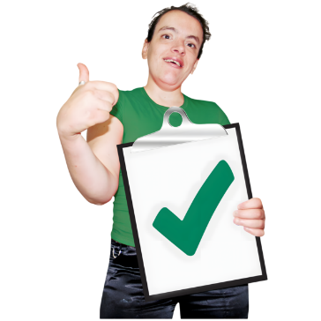
Why should I take part?
You will help us see what changes need to happen that may help make disabled people’s lives better.

Are there any risks?
Someone might be able to recognise you from your story when we write about it.

What will happen with my information?
We will keep your details on our computer and database in a password protected file.
We will change your name and anything else that could let people know who you are.
We can delete your survey if you have told us your name.

What will happen with the research?
We will write a report and make a video to share online and in meetings.

If you feel you need help or information about the things in our survey you can get in touch, and we will try and help.

You can e-mail us - research@inclusion-glos.org
Or call us on 07517994765

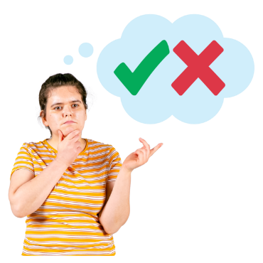

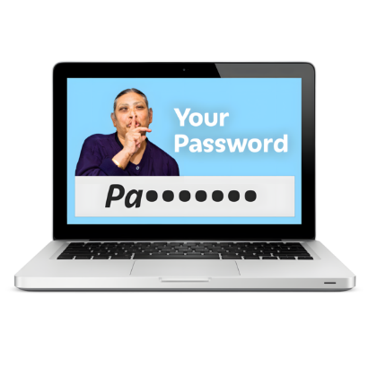

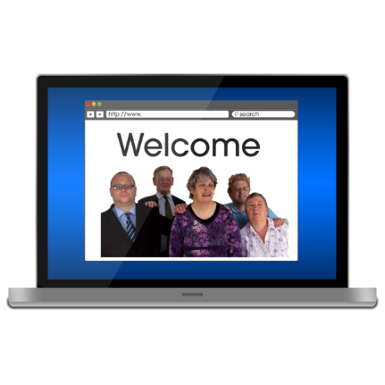



Agreeing to take part – Please tick your answer
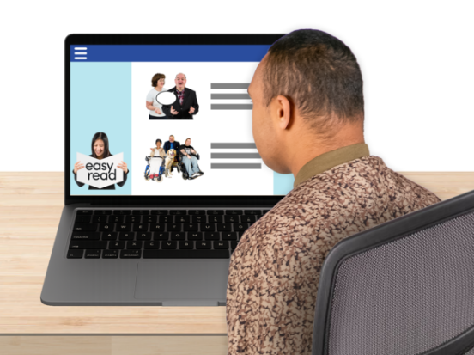
I have read and understood the information on the page before, or someone has explained it to me and I understand.
Yes
No



I have had the chance to ask questions about the research.
Yes
No

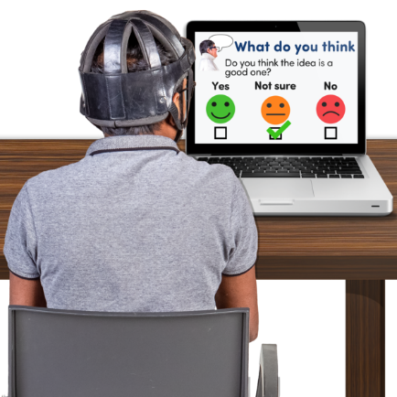
I understand that taking part means I will fill in a survey.
Yes
No



I understand that I do not have to take part, and I can change my mind after I start. I also understand that after I have sent my responses, Inclusion Gloucestershire will not be able to delete them
Yes
No
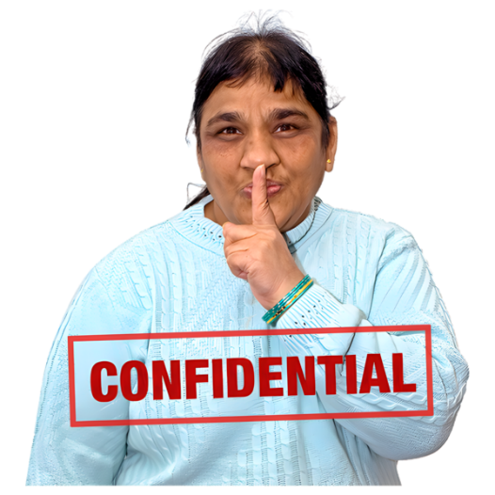

I understand that my details will not be shared with anyone outside of the research team unless there are concerns for my safety or the safety of others. Participants have the option to share their contact details with us so they can receive the report directly.
Yes
No

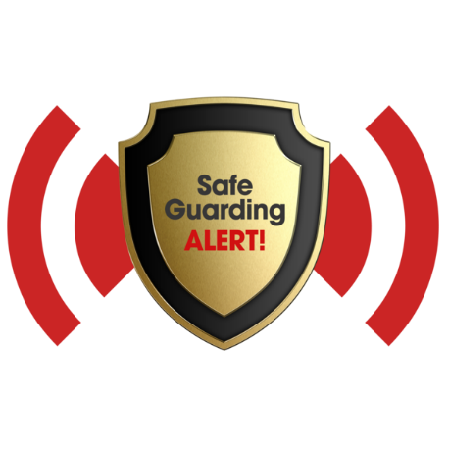
I understand that if at any point Inclusion Gloucestershire need to break confidentiality, they will let me know that they need to pass this information on and will follow Inclusion Gloucestershire’s safeguarding policy.
Yes
No

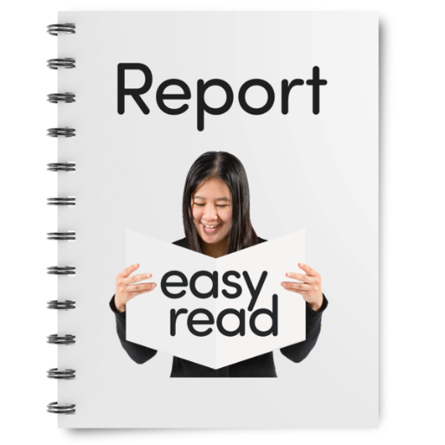
I understand that my answers may be written in a report or on a video and shared with other people, but my name won’t be used.

Yes
No



I allow Inclusion Gloucestershire to safely store my survey on a laptop to use in more research in the future.
Yes
No

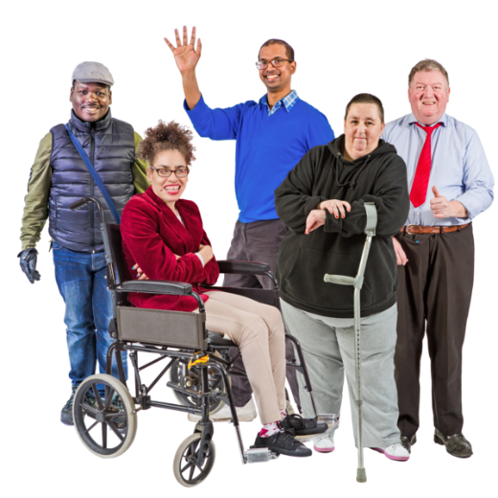
Please tell us about your disability. A disability is a 'physical or mental impairment that has a substantial and long-term adverse (negative) effect on your ability to carry out normal day-to-day activities'. If you have more than one disability, please select all that apply.
ADHD
Autism
Chronic Illness
Hearing impairment
Learning Disability
Mental health condition
Neurological condition
Physical impairment
Sight impairment

Other

Are you aged 18 or over?
Yes
No

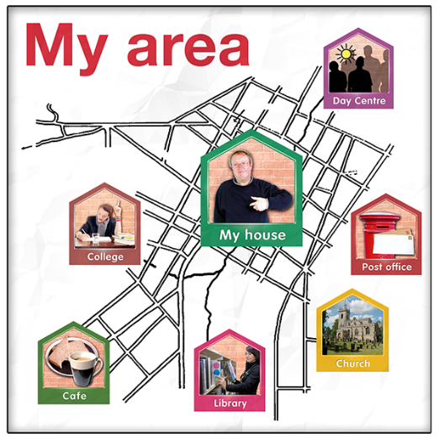
Do you live in Gloucestershire?
Yes
Yes – some of the year I spend in Gloucestershire as a student
No – sorry you cannot complete this survey.

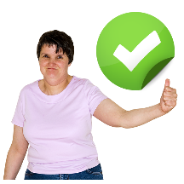
To answer the questions in the survey, put a tick or colour in the circle that best describes how you feel.

Section 1 is about your life and support.
1 | 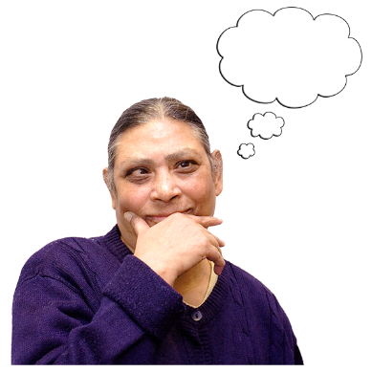  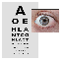 | How do you feel about getting help with your health? This could be your GP, hospital, or other health things.  Very happy  A little happy  Not sure  Not too happy  Not happy at all  This is not about me
1 | Tell us more about your answer:

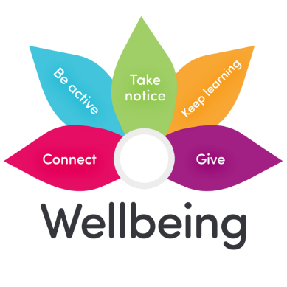  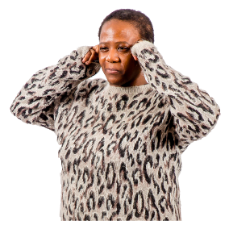  2 |  | How do you feel about getting help with your mental health or feelings?  Very happy  A little happy  Not sure  Not too happy  Not happy at all  This is not about me
 | Tell us more about your answer:

3a. | 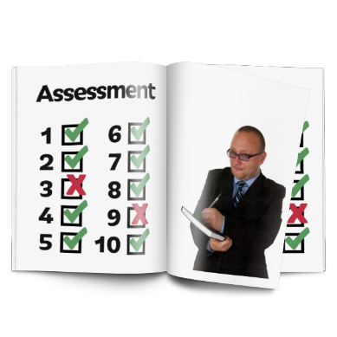 | If you get help from social care, how do you feel about getting an assessment or review?  Very happy  A little happy  Not sure  Not too happy  Not happy at all  This is not about me
3a. | Tell us more about your answer:

3b. |  | How happy are you with the involvement you have with making decisions about your social care?  Very happy  A little happy  Not sure  Not too happy  Not happy at all  This is not about me
3b. | Tell us more about your answer:

3c. |  | How happy are you with how social care supports you to be as healthy and independent as you can be?  Very happy  A little happy  Not sure  Not too happy  Not happy at all  This is not about me
3c. | Tell us more about your answer:

4 | 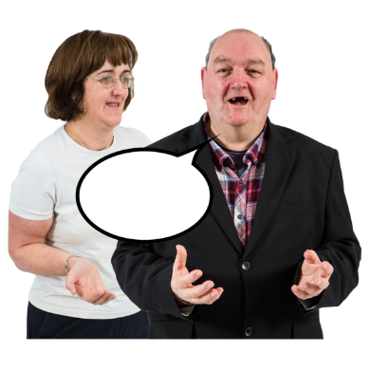 | How do you feel about getting help to speak up for yourself? This is called Advocacy.  Very happy  A little happy  Not sure  Not too happy  Not happy at all  This is not about me
4 | Tell us more about your answer:

5 | 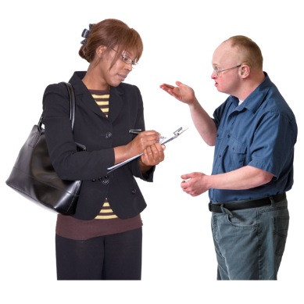 | How do you feel about telling the people who support you when things are going well and not so well?  Very happy  A little happy  Not sure  Not too happy  Not happy at all  This is not about me
5 | Tell us more about your answer:

6 | 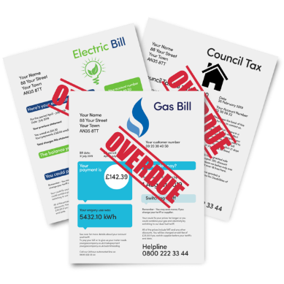 | How do you feel about things like paying your bills and having enough money?  Very happy  A little happy  Not sure  Not too happy  Not happy at all  This is not about me
 | Tell us more about your answer:

7 | 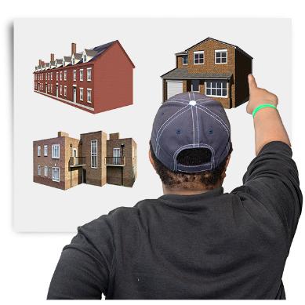 | How do you feel about where you live?  Very happy  A little happy  Not sure  Not too happy  Not happy at all  This is not about me
7 | Tell us more about your answer:

8 |  | How do you feel about getting help to find and keep a job or be a volunteer?  Very happy  A little happy  Not sure  Not too happy  Not happy at all  This is not about me
8 | Tell us more about your answer:

9 | 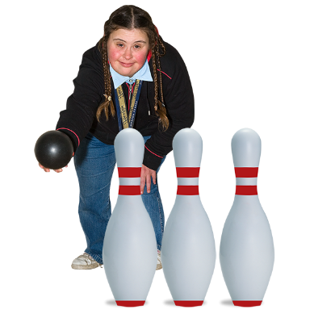 | How do you feel about being able to go out to do things you enjoy?  Very happy  A little happy  Not sure  Not too happy  Not happy at all  This is not about me
9 | Tell us more about your answer:

10 | 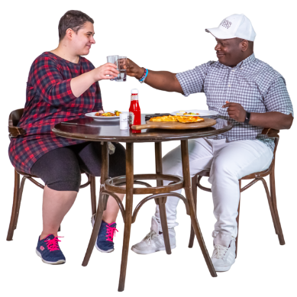 | How do you feel about being able to see your friends, family or other people who are important to you?  Very happy  A little happy  Not sure  Not too happy  Not happy at all  This is not about me
10 | Tell us more about your answer:

11 |  | Are you happy with the attitudes professionals and services have towards your sexuality or gender identity?  Very happy  A little happy  Not sure  Not too happy  Not happy at all  This is not about me
11 | Tell us more about your answer:

12 | 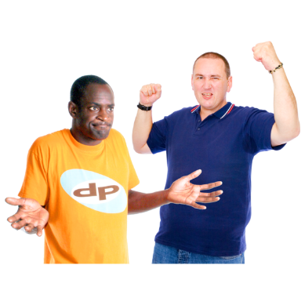 | Are you worried that you have been treated differently or badly this year because of who you are, like your religion or disability or race or other things? This is called discrimination.  Very worried  A bit worried  Not sure  Not too worried  Not worried  This is not about me
12 | Tell us more about your answer:

13 | 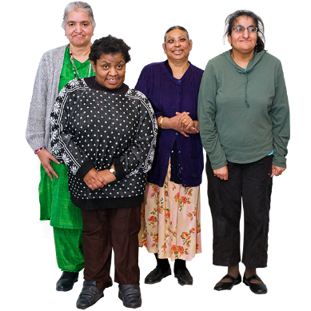 | Are you happy with the attitudes professionals and services have towards your culture and/or religion?  Very happy  A little happy  Not sure  Not too happy  Not happy at all  This is not about me
13 | Tell us more about your answer:

14 | 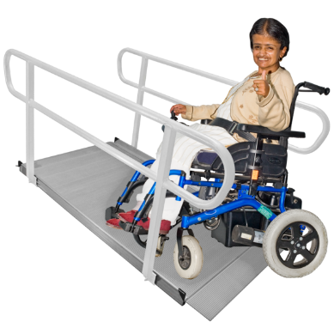 | How do you feel about accessing different places? This could be things like getting in and out, being able to understand signs, being too busy, or too bright or having hearing loops.  Very happy  A little happy  Not sure  Not too happy  Not happy at all  This is not about me
14 | Tell us more about your answer:

15 | 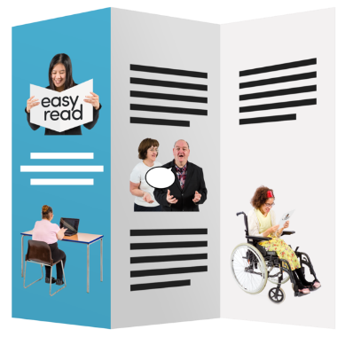 | How do you feel about getting easy to understand information that you might need, for example from your GP, banks, buses, and other things?  Very happy  A little happy  Not sure  Not too happy  Not happy at all  This is not about me
15 | Tell us more about your answer:

16 |  | How do you feel about how safe you feel when you are not at home?  Very happy  A little happy  Not sure  Not too happy  Not happy at all  This is not about me
16 | Tell us more about your answer:

17 | 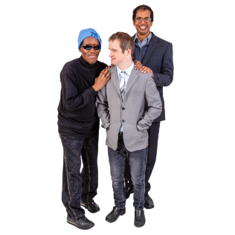  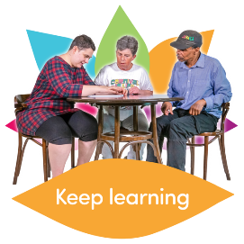  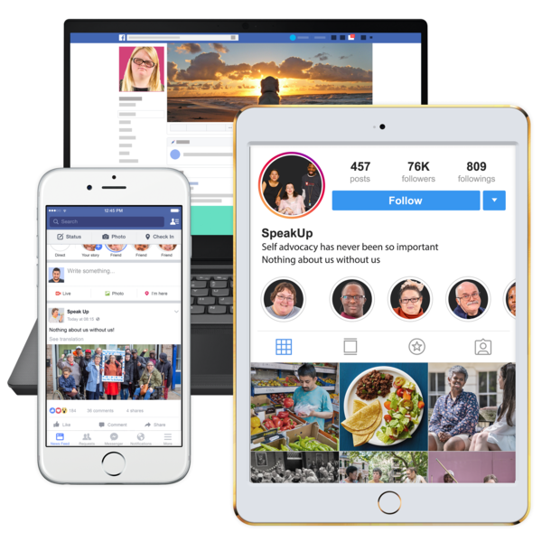  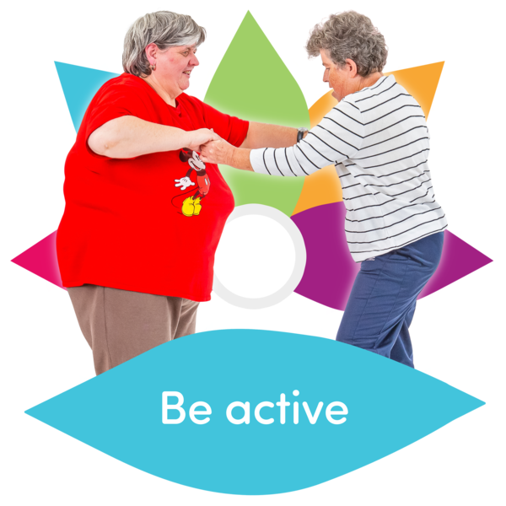 | Is there anything we haven’t asked about that is worrying you?  Education  Access to exercise  Using technology  Looking after someone like your parent or  child  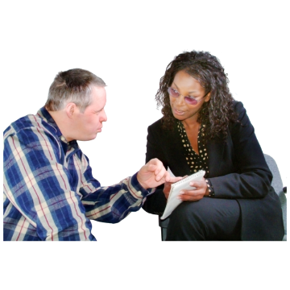  Getting reasonable adjustments in work  ?  Something else
17 | Tell us more about your answer:
18 |  | Can you say here what you are worried about most?

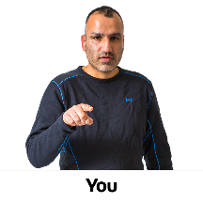
Section 2 These are questions about you.
We would like everyone to fill in these questions so we can find out what is worrying different people.
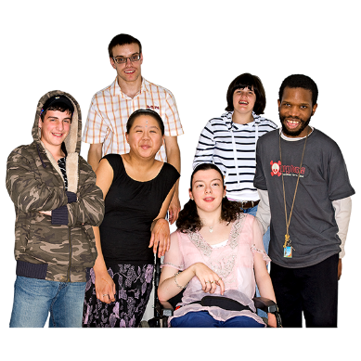
Please tick or colour the circle that best describes you.
Male
Female
Not male or female, this is called non-binary
Both male and female, this is called intersex
Not saying
Something else

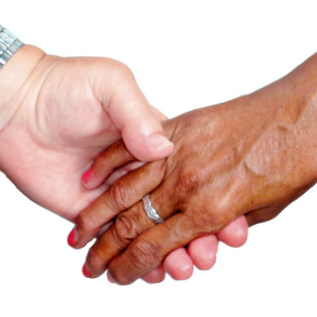

Are you trans/transgender? This means you are a different gender than the one you were when you were born.
Yes
No
Not saying
Something else

Who do you prefer to have a romantic relationship with? This is called sexual orientation.
People of the opposite sex to you
People of the same sex as you
People of the same sex and different sex to you
Not saying
Something else

How old are you?
Under 18
18-24 44-54
25-34 55-64
35-44 65-74
Not saying Over 75

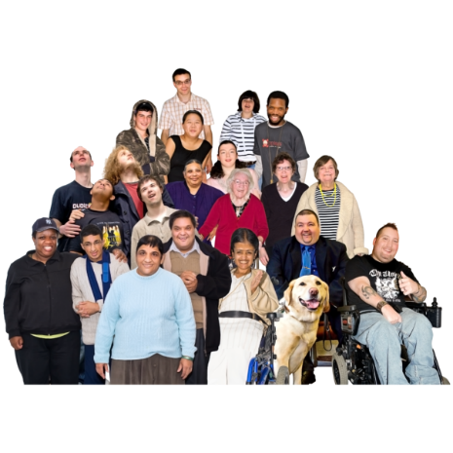
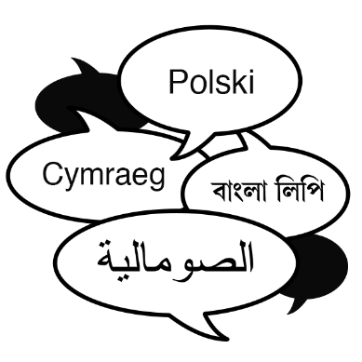
Please tell us which in this list best describes you.
Not saying
Arab
Arab British
Asian or Asian British - Indian
Asian or Asian British - Pakistani
Asian or Asian British - Bangladeshi
Asian or Asian British - Chinese
Asian or Asian British - Any other Asian background
Black or Black British - Caribbean
Black or Black British - African
Black or Black British -Any other Black background
Mixed - White and Black Caribbean
Mixed - White and Black African
Mixed - White and Asian
Any other Mixed background
White British
White Irish
Any other White background
Something else
Is English your first language?
Yes
No
Not saying
Something else

Please tick or colour the circle in this list next to where you live in Gloucestershire.
Cheltenham
Forest of Dean
Gloucester
Stroud
Tewkesbury
The Cotswolds
Not saying
Somewhere else
Have you been using any of Inclusion Gloucestershire's services in the last 6 months? This might be the Inclusion hubs, drama group, advocacy support, speak up groups or MHELO (Mental Health Experience Led Opportunities).?
Yes
No
Not sure
Not saying
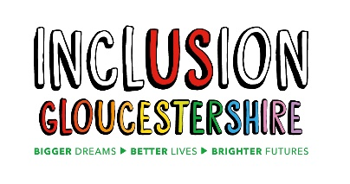
Are you a member of Inclusion Gloucestershire?
Yes
No
Not sure
Not saying

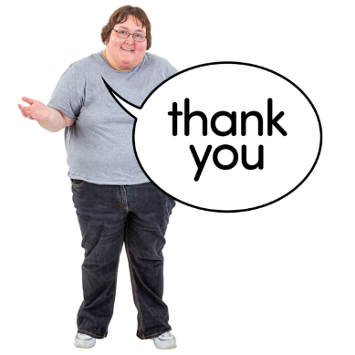

Thank you.
If you don’t want to fill in section 3 you can send us your survey with your answers. Our address is at the end of the survey.

Section 3 your contact information.
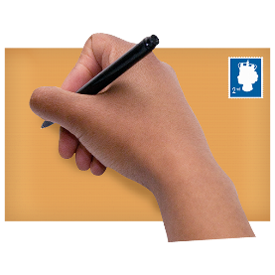
We would like to be able to contact you, but you don't have to give your contact details to us if you don't want to.

If you do give us your information, we will only use it to:
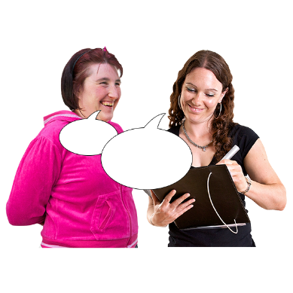
1) to talk to you to find out more about your answers to this survey
2) to send you a copy of the report.

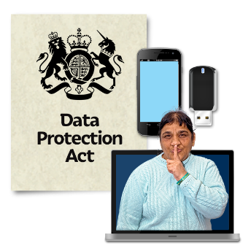
We will keep your personal contact details safely for 1 year from the date the survey closes.

To find out more about how we keep information safe or to tell us you do not want us to keep your information please email research@inclusion-glos.org

We will not share your personal details with other people or organisations.

Please tell us your full name.

Please tell us your phone number.
Please tell us your email address.

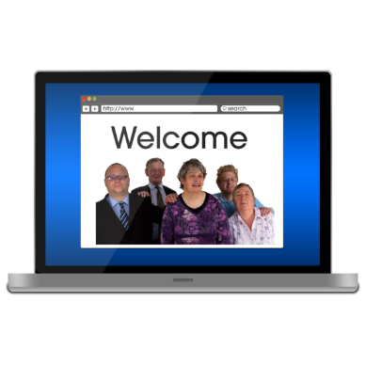
Please keep an eye on our website and social media as we will share information about what you have told us on these.

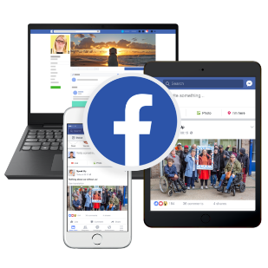
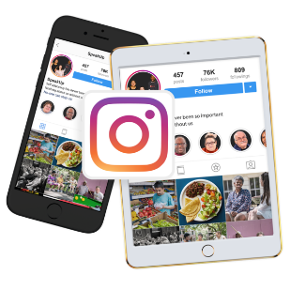
https://www.inclusiongloucestershire.co.uk/research-strategy-and-partnerships/

https://www.facebook.com/inclusionglos/

https://www.instagram.com/inclusiongloucestershire/

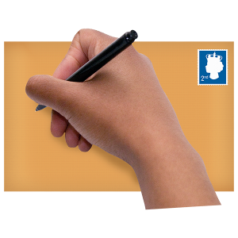
If you want to post your survey back to us,
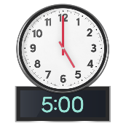
please post your survey by
5pm on 30th September 2026 to us at:

Inclusion Gloucestershire
Railway House
Bruton Way
Gloucester
GL1 1DG
Thank you for helping us with our survey


