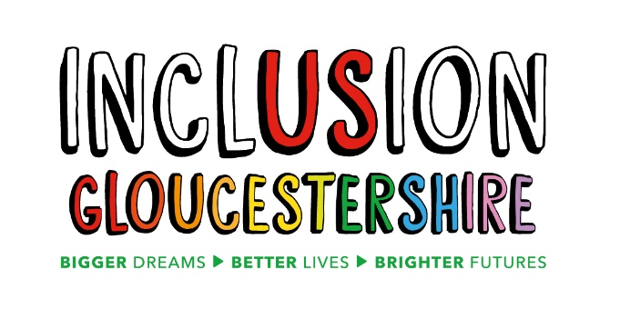

Trustee Position (Voluntary)
Summary of the role
Inclusion Gloucestershire is a vibrant, successful Disabled People’s Organisation and registered charity. We are looking for a new addition to join our board of trustees who help to lead the charity’s direction and play a key role in strategic decisions. The trustee will need to attend board meetings every other month and be involved in communication with the board and CEO throughout the year.
Role Purpose: To work with the other trustees providing valuable insight regarding the charity’s key decisions to ensure the charity:
- Delivers benefit for people who face disabling barriers
- Is well governed in line with its governing document and the law
- Ensures resources are managed responsibly
- Is accountable in line with statutory accounting and reporting requirements
Reports to: Chair of the Board

Essential Skills/Experience
- Good communication skills
- Patience and understanding
- Takes pride in their work
- A team player
- Dedicated and committed
- Shares Inclusion Gloucestershire values and personal beliefs (see next page)
We are currently considering applicants from:
- People who face disabling barriers (with lived experience such as physical disabilities, learning disabilities, mental-ill health and those from backgrounds of neurodiversity)
- Unpaid carers
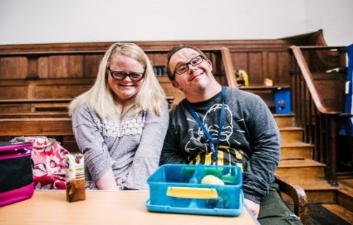

Values and Personal Beliefs
Inclusion Gloucestershire is driven by its values, at the heart of all that it does. Teams are expected to share and demonstrate these values:
- We are a user-led organisation, driven by the social model of disability, which sees people as disabled by society rather than by their impairment or difference.

- We make sure everyone is meaningfully involved and included

- We empower choice and control through peer leads and place experts by experience at the forefront of our delivery

- We challenge when things aren’t right and give people facing disabling barriers a strong voice

- We believe it is right to treat people fairly and always behave in a way that is honest and trustworthy even when nobody is looking

- We are a caring and professional organisation who work together towards shared goals

- We work in partnership to deliver exciting new ideas and support each other, our members and our community.

Application process:
- Complete application form
- Applications will be short-listed for a meeting and informal interview with 2-3 current trustees
- Final stage applicants will be invited to a Board Meeting to find out if this is a mutually good fit (Thursday 11th November 2021)
If you would like to know any additional information prior to your application or would like some additional support with your application, please let us know and we would be happy to assist

For further queries/information, please contact our CEO Vicci. For any general background about Inclusion Gloucestershire, please visit our web site at https://www.inclusiongloucestershire.co.uk/

Deadline for application consideration: Sunday 17th October 2021

