

Trustee Position (Voluntary)
Summary of the role
Inclusion Gloucestershire is a vibrant, successful Disabled People’s Organisation and registered charity (charity number 1171559). We are looking for people to join our board of trustees to help to lead the charity’s direction and play a key role in strategic decisions. Trustees need to attend board meetings every other month and be involved in communication with the board and CEO throughout the year.
Role Purpose: To work with the other trustees providing valuable insight regarding the charity’s key decisions to ensure the charity:
- Does great work for people who face disabling barriers
- Is well governed (run) in line with its governing document and the law
- Manages resources (like money and people) responsibly
- Is meeting the requirements of the law with its accounting and reporting
As a Disabled People’s Organisation, we are run by disabled people for disabled people. At least 75% of the Board must have lived experience so we especially welcome interest from disabled people, and other people who may be under represented at a Board level.
Reports to: Chair of the Board
Commitment
3-4 hours per month in meetings, calls, discussions and board meeting preparation.
Expenses and access
This role is not paid. We will pay reasonable travel and access costs to attend meetings.
Essential Skills/Experience
- Good communication skills
- Patience and understanding
- Takes pride in their work
- A team player
- Dedicated and committed
- Shares Inclusion Gloucestershire values and personal beliefs (see next page)
We want the work of our Board to be as accessible and inclusive as possible. We can share information (including board papers) in different ways, like Easy Read or video updates. Please let us know if there are any reasonable adjustments we can make for you.
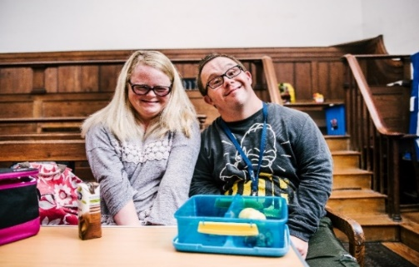
Values and Personal Beliefs
Inclusion Gloucestershire is driven by its values, at the heart of all that it does. Teams are expected to share and demonstrate these values:
- Value lived experience – as an organisation led by disabled people, for disabled people
- Respect – each other, our community, our environment and our partners
- Include – a broad range of lived experiences, because we are better together
- Empower – strong voices and choice and control for people facing disabling barriers
Application process:
- Complete application form
- Applications will be shortlisted for a getting to know you interview with 2-3 trustees and the CEO on the week commencing 8th December 2025
- Successful applicants will be appointed at the AGM on Wednesday 4th February 2026
If you would like to know any additional information prior to your application or would like some additional support with your application, please let us know and we would be happy to assist. Applications can be submitted as a video or audio recording, or as a written form.

Please note that to manage conflicts of interest, trustees cannot also be employed by the charity, or have been employed by us in the previous 12 months.
For further queries/information, please contact info@inclusion-glos.org or phone 01452 234003. For information about Inclusion Gloucestershire, please visit our website at https://www.inclusiongloucestershire.co.uk/

Deadline for applications: Sunday 30th November 2025 at midnight

