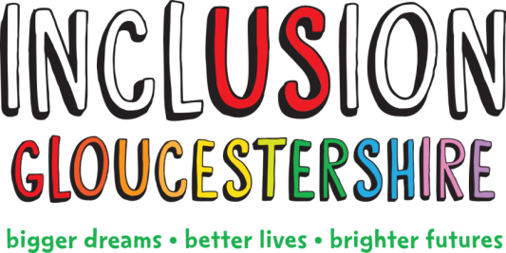

Job Description – Friendship Hub Expert by Experience
Summary of the Role
This job is helping to run an Inclusion Hub for one day a week from the Friendship Café in Gloucester. It is for people from Black, Asian and minority ethnic (BAME) communities with disabilities. The Hub will offer opportunities for people to have their say, talks on healthy living, information, support and activities.
This project is important because people from BAME communities are more likely to have poorer health and not be as well supported as other people.
This role sits within the Engagement team, alongside Project Coordinator, Project Worker and the Engagement Manager
You will have lived experience of disability (physical, learning or mental ill health) and will be an expert in making sure people are included. You will work with a colleague who has experience of getting people from many different backgrounds involved.
Job Purpose: To be a visible peer lead at the Friendship Hub, making it a welcoming safe space and championing the work that we do.
Reports to: Friendship Hub Coordinator
Main Duties and Responsibilities
- To support in the everyday running of the Friendship Hub. This will include welcoming people, and helping run activities
- Talking to people about the importance of our work
- Representing the views of people with disabilities in Gloucestershire at events in and out of county
- Helping to run a range of activities and events at the Friendship Hub and in the wider community
- Ensuring that our Friendship Hub is user-led by experts by experience
- Talking with peers and building their confidence to be included in the way the Friendship hub is run
- Ensuring and maintaining professional working relationships and boundaries with Hub members, staff, volunteers and external organisations
- Working with people to capture their voices, stories and work with people to create action plans
- Being aware and act on the need to report safeguarding concerns
- Helping to keep participants and staff safe and confident in their surroundings and act on safeguarding and health and safety concerns in line with Inclusion Gloucestershire’s policies
- Advocating for Inclusion Gloucestershire and its projects at meetings and events and within your own appropriate networks
- Completing appropriate training

This role profile is not exhaustive and may be subject to change to meet the operational needs of the organisation.

Essential Skills/Experience
- Able to travel independently to and from the Friendship Hub
- Good communication skills and ability to easily build rapport with individuals, staff and volunteers
- Trustworthy and able to handle confidential information
- Reliable
- Team player
- Willing to learn
- Friendly, caring and understanding
- Positive, enthusiastic and able to lead by example
Desirable Skills/Experience
- Able to read and write English
- Experience of a range of support services for people facing disabling barriers. This could be as a disabled person or in the role of staff, management, family/carer.
- Ability to communicate in different languages
- Experience of supporting or working with people facing disabling barriers
- Experience of supporting or working with BAME communities (families/groups etc.)
- Understanding of safeguarding and health and safety (training will be provided)

Values and Personal Beliefs
Inclusion Gloucestershire is driven by its values, at the heart of all that it does. Teams are expected to share and demonstrate these values:
- Make sure everyone is involved and included
- Empower choice and control through peer support and place experts by experience at the centre of our delivery
- Challenge when things aren’t right and give people with disabilities a strong voice
- Treat people fairly and always behave in a way that is honest and trustworthy even when nobody is looking
- Be a caring and professional organisation who work together towards shared goals
- Work together to deliver exciting new ideas and support each other, our members and our community.

Due to the nature of the work carried out in the Friendship Hub this role is restricted to female applicants only in accordance with the provisions of the occupational requirement (Equality Act 2010, pursuant to Schedule 9, Part 1).

