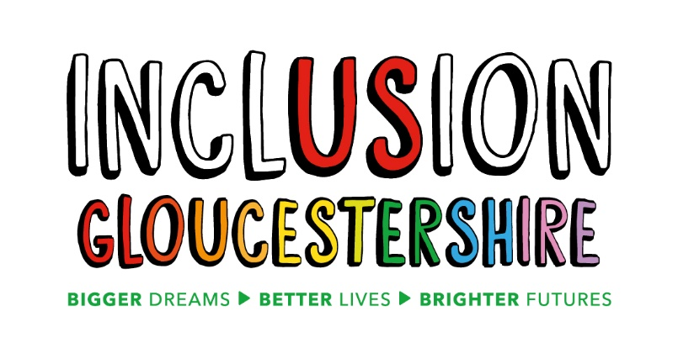
Job Description – Oliver McGowan Mandatory Training Expert by Experience
About our organisation
Inclusion Gloucestershire is a registered charity and a growing, successful user-led organisation (ULO), run by disabled people for disabled people. We believe that disabled people should be involved, included and valued by society every day and in every way, and we run a range of projects to make this happen. Our user-led services include Hubs in three districts, MHELO (a mental health per support network), supported volunteering and advocacy and mentoring. We also provide training and development that builds upon and showcases the brilliant skills of disabled people through a range of methods including drama. Another part of our work is quality checking care and support services in working with providers to make sure that care and support is as good as it possibly can be. You can find out more about our work at: https://www.inclusiongloucestershire.co.uk/
Summary of the Role
This role is part of a new partnership project with Gloucestershire Health and Care Foundation Trust to deliver training about learning disabilities and autism to health and social care staff.
Inclusion Gloucestershire will make sure that the training is designed and delivered with Experts by Experience, who live with a learning disability or autism. The training will include:
- Learning disability awareness
- Understanding autism
- Reasonable adjustments
- Supporting people with mental health conditions
- Communication
- Supporting young people with a learning disability.
We deliver training in really interesting ways that help people change their ways of thinking. This training will take place both through e-learning (online training) and through face to face training sessions to groups of up to 100 people.
The training team for this project will include a Manager, other Experts by Experience and a Coordinator who the Experts by Experience will work alongside to design and deliver the training. The Coordinator will support and manage the Experts by Experience in their role.
Job purpose: To work in a team to help design, and deliver really interesting training about learning disabilities and autism.
Reports to: Oliver McGowan Mandatory Training Coordinator
Main Duties and Responsibilities
- Work with the rest of the team to design what is covered in the training, and make sure that the voice of people with a learning disability or autism is at its heart.
- Co-deliver training sessions alongside the Coordinator and other Experts by Experience. The sessions will use a range of methods, including traditional training delivery, group discussions, and film.
- Take part in rehearsals and practice runs to develop skills and confidence to deliver great training!
- Develop good working relationships with the rest of the team
- Make sure that you are in the right place at the right time, and well prepared to deliver training sessions
- Be professional, friendly and welcoming to people coming to the training
- Work with the rest of the team to look at what is working well in the training and what could be improved
- Help to promote the training and make people aware of it, and encourage them to attend.
- Attend meetings and training to develop relevant skills and knowledge and ensure consistent and high-quality delivery
- Help to keep participants and staff safe and confident in their surroundings and act on safeguarding and health and safety concerns in line with Inclusion Gloucestershire’s policies.
- Advocate for Inclusion Gloucestershire and its projects at meetings and events and within your own appropriate networks.
- The role may include some evening and weekend work

The role requires the ability to travel independently across all of Gloucestershire
This role profile is not exhaustive and may be subject to change to meet the operational needs of the charity.

Essential Skills/Experience
N.B. Those items marked * will be used as shortlisting criteria for this post
- Experience of living with a learning disability or autism*
- Comfortable talking in front of groups of people (up to 100)*
- Experience of presenting or talking in front of people*
- Able to learn and remember what needs to be said when delivering training (support will be provided)
- Great at communicating and making people comfortable
- Reliable
- Trustworthy and able to keep information confidential
- Able to travel independently throughout the county
- Able to get on with others and be a team-player, as well as the ability to take direction
- Positive outlook, energy, focus and enthusiasm
- Resilient, calm and professional
- Willing to learn and open to new opportunities
- Flexible and able to work weekends and evenings when required

Desirable Skills/Experience
- Experience of delivering training
- Experience of working with the health and/or social care sector

Values and Personal Beliefs
Inclusion Gloucestershire is driven by its values, at the heart of all that it does. Teams are expected to share and demonstrate these values:
- Make sure everyone is involved and included
- Empower choice and control through peer support and place experts by experience at the centre of our delivery
- Challenge when things aren’t right and give people with disabilities a strong voice
- Treat people fairly and always behave in a way that is honest and trustworthy even when nobody is looking
- To be a caring and professional organisation who work together towards shared goals
- Work together to deliver exciting new ideas and support each other, our members and our community.

January 2021

