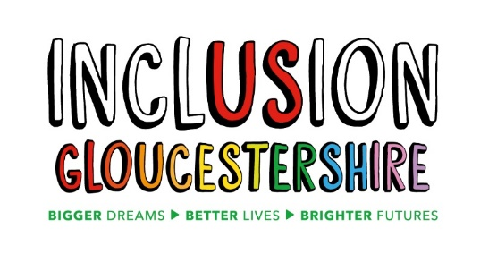

Job Description – NHS Engagement Expert by Experience Project Worker

What does this job do?
This project works with the NHS to make sure that people with a learning disability (Experts by Experience) have a voice when it comes to planning and delivering health services.

We will do this by supporting people to set up more self-advocacy groups across the South West, and by bringing people from different self-advocacy groups together to have a really strong voice on health issues and other important matters.

This job is for a person with a learning disability who will lead the project with another Expert by Experience and other team members.

The job is to talk with people with a learning disability and encourage them to speak up for themselves and others as a way to ensure that the voices of people with a learning disability are heard.

The team who work on this project, will keep in touch with people with a learning disability about having their views, choices and health issues heard, and with the wider public about disability issues. They will do this by talking, writing information and sharing it and by listening to good ideas.

Job purpose: To work with a Coordinator and another Project Worker, to set up more self-advocacy groups across the South West and make sure that people with a learning disability feel they can have their voices heard.

Reports to: Project Coordinator

Main Duties and Responsibilities
The duties of the Project Worker will include:
- Having regular meetings with NHS professionals to discuss important things, ideas, feedback on health issues etc. These meetings may be face to face or on video calls
- Having regular meetings with people with learning disabilities from different parts of the south west of England. These meetings may be face to face or on video calls
- Sending emails and making telephone calls to lots of different people
- Keeping notes of your work and sharing them with other people
- Looking for information to make sure that we know what is happening and how to support better self-advocacy and better health for people with a learning disability. This is sometimes called research
- Organising meetings and sending information to people
- Joining in staff meetings
- Being aware of the need to report safeguarding concerns
- Helping to keep everyone safe and confident in their surroundings and act on safeguarding and
- Following the rules for health and safety in line with Inclusion Gloucestershire’s policies.
- Advocate for Inclusion Gloucestershire and its projects at meetings and events and within your own networks.

There may be other duties as the project changes

Essential Skills/Experience
- Lived experience of learning disability (this role is for someone with a learning disability)
- A good understanding of the health needs of people with a learning disability
- A good understanding of self-advocacy
- Excellent communication skills (listening and talking).
- Great at talking with and building relationships with new people.
- Enthusiastic and keen to improve services and support for people with learning disabilities.
- Strong commitment to people having a voice
- Be able to work independently and remotely
- Good at organising your own work
- Good timekeeping
- Ability to use a computer e.g. to send and receive emails, use a spreadsheet, write notes and use the internet to research
- Comfortable using video calling programmes especially MS Teams or/and Zoom
- Able to travel independently on public transport.
- If working from home, be able to commit to travelling to the Inclusion Gloucestershire Office up to 2-3 times a month)

Values and Personal Beliefs
Inclusion Gloucestershire is driven by its values, at the heart of all that it does. Teams are expected to share and demonstrate these values:
- Make sure everyone is involved and included
- Empower choice and control through peer support and place experts by experience at the centre of our delivery
- Challenge when things aren’t right and give people with disabilities a strong voice
- Treat people fairly and always behave in a way that is honest and trustworthy even when nobody is looking
- To be a caring and professional organisation who work together towards shared goals
- Work together to deliver exciting new ideas and support each other, our members and our community.

Nov 2020

