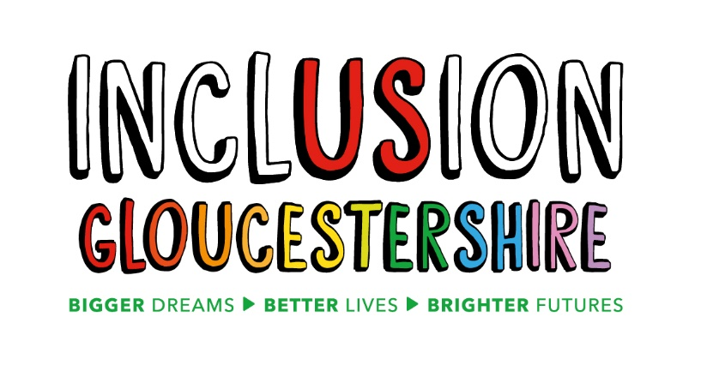
Job Description – Training and Development Manager
Summary of the Role
The Training and Development Manager will lead a team of people including some who are Experts by Experience to further develop our Training and Development offer, consisting of the Dramatic Change drama group and our training offer which utilises both drama and more traditional training methods.
Dramatic Change is Inclusion Gloucestershire’s drama team, who take an issues-based approach to developing information, advice, awareness-raising and training through drama and film productions that are co-produced by people with lived experience of disability, autism or mental ill health. Previous films have covered topics such as hate crime, sexual abuse, bereavement, reasonable adjustments, and supported housing.
Regular drama workshops will take place for people with a range of disabilities as well as non-disabled people with the intended outcome of producing at least four issue based films and training opportunities.
We are in the process of building our Expert by Experience Training offer and this will be a key role for the Training and Development Manager. Recent training courses have included communication, disability awareness, person centred approaches and values. We have delivered Forum Theatre training to a range of external organisations on topics such as bereavement and self-neglect and the intention is to continue with this.
Finally, we are expanding our Easy read translation and training offer (Easy Read with Inclusion Gloucestershire - EARWIG) and this work will be part of the training and development team
The Training and Development Manager role involves leading, managing and developing the training and drama projects and the Easy Read Service. This will include planning and delivering productions and training, project management and monitoring, marketing of our offer, leadership and development of the staff team and working with individuals to ensure they achieve their potential.
Job purpose: To lead, develop, monitor and report on the Dramatic Change project ,Training offer and Easy Read Service, ensuring that staff are well supported, participants have a fully inclusive and positive experience of drama and training, and the project delivers against deadlines and targets to the highest possible standards.
Reports to: Delivery Director
Main Duties and Responsibilities
- Produce a 3-year project plan, annual project plans, and implement and update and report to senior management and funders to show progress against key deliverables and development targets.
- Analyse performance against plan and targets and make adjustments consistent with meeting deliverables, growth targets and objectives.
- Select, lead, manage, support, appraise and develop Dramatic Change and Training team members ensuring staff and volunteers are fulfilling their role to the best of their abilities.
- Ensure that all team members understand their roles, accept their responsibilities and deliver against targets.
- Identify income generation and business development opportunities and prepare funding bids, with the support of the Senior Management Team.
- Manage project resources (including people) within budget and according to the approved project plan.
- Lead on other projects that may be established and ensure effective delivery
- Work effectively with the team and partner organisations keeping them informed of progress and issues as well as working cooperatively and ensuring the quality of stakeholder relationships is second to none.

- Help to keep participants and staff safe and confident in their surroundings and act on safeguarding and health and safety concerns in line with Inclusion Gloucestershire’s policies.
- Advocate for Inclusion Gloucestershire and its projects at meetings and events and within your own appropriate networks.
- Help foster a positive, supportive team culture for staff and participants alike.
- Lead on the development and delivery of high quality film and live theatre productions including research, devising, workshop delivery, film/music editing and directing.
- Work flexibly across the roles of actor, director, producer, coach and project manager whilst maintaining overall responsibility for the project.
- Develop good working relationships with the Dramatic Change and training project team including freelance staff and volunteers.
- Lead on the development and delivery of high-quality expert by experience training and easy read offers.
- The role may include some evening and weekend work

This role profile is not exhaustive and may be subject to change to meet the operational needs of the charity.

Essential Skills/Experience
N.B. Those items marked * will be used as shortlisting criteria for this post
Managerial
- Experience of leading or managing a diverse staff team*
- Experience and knowledge of project management and budget management*
- Able to of monitor KPIs, impact and report to funders and others on these*
- Proven leadership ability
- Able to self-manage; set deadlines and targets and meet them*
- Able to both market and represent the service
- Able to generate new business and income generation opportunities
- Excellent verbal and written communication skills and confident in Information Technology including social media
Job specific
- Flair for generating creative ideas and the ability to present them to others and encourage others to do so
- Understanding of disability, autism and mental ill health
- Excellent report writing skills and ability to analyse data*
- Understanding of how to manage safeguarding and health and safety (training will be provided)
- Able to travel throughout the county independently
- Able to work flexibly with the possibility of occasional evening and weekend work
Personal Characteristics
- Reliable and adaptable*
- Enthusiasm, positivity, patience and self-discipline
- Inclusive and tolerant
- Able to build rapport and engage with people with a variety of disabilities/needs
- Exemplary time management and the ability to prioritise*
- Able to work under pressure
- Trustworthy and able to handle confidential information*
- Able to build and maintain strong working relationships with external/partner organisations*
- Sensitive and effective communicator
Desirable Skills/Experience
- Experience of script writing, staging live theatre productions and directing filmed productions
- Good working knowledge of the dance and performing arts industry
- Experience of delivering creative training
- Experience of developing e learning
- Knowledge of nonverbal communication methods, e.g. Makaton
Values and Personal Beliefs
Inclusion Gloucestershire is driven by its values, at the heart of all that it does. Teams are expected to share and demonstrate these values:
- Make sure everyone is involved and included
- Empower choice and control through peer support and place experts by experience at the centre of our delivery
- Challenge when things aren’t right and give people with disabilities a strong voice
- Treat people fairly and always behave in a way that is honest and trustworthy even when nobody is looking
- To be a caring and professional organisation who work together towards shared goals
- Work together to deliver exciting new ideas and support each other, our members and our community.

July 2020

