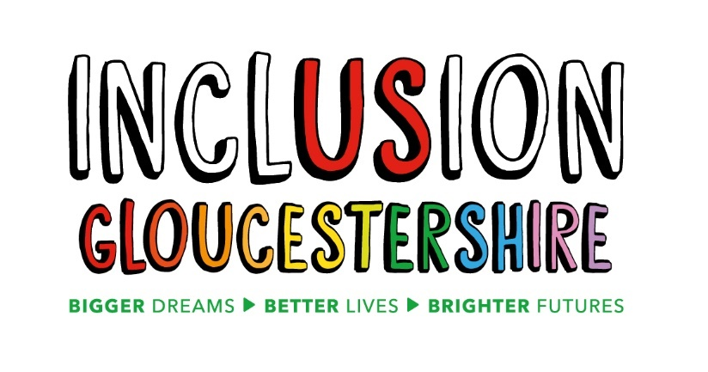

Job Description – Volunteer Coordinator
Summary of the Role
This role sits within the Engagement team in an exciting project funded by the National Lottery delivering Inclusion Gloucestershire’s supported Volunteering offer. The Volunteer Coordinator will recruit, support, line manage and develop a range of volunteers with varying skills, experience and support needs to contribute to our work in a meaningful, safe and valued way.
Job Purpose:
- Lead on the design and delivery of a volunteer offer targeting both those who can add capacity to the organisation and also those who wish to volunteer with us to develop confidence and skills.
Reports to: Community Projects Manager
Main Duties and Responsibilities
- Liaise with project leads to identify and understand volunteering requirements and opportunities within their projects
- Plan and manage the ongoing recruitment, induction and development process for volunteers, and support individuals through this journey
- Match volunteers up with opportunities based on their skills, capabilities, experience and availability
- Deliver a varied skills-based volunteer programme that links with other areas of the organisation
- Support people facing a range of disabling barriers to engage and participate in volunteering, and develop their skills and confidence in the role
- Provide logistical support including organizing training, induction and ongoing support sessions for volunteers, and ensure that they fully understand their roles, commitments and responsibilities, in line with the Volunteer Agreement
- Support volunteers and project leads when things aren’t going right in a volunteering relationship, with an aim to resolve any difficulties
- Follow and regularly review processes used within the project, identifying and initiating areas for improvement
- Collate and report on key data required for monitoring purposes, ensuring delivery to contractual targets and KPIs
- Plan, organize and coordinate a series of one-off volunteering engagement events and opportunities throughout the year
- Proactively identify and report safeguarding concerns, following our Safeguarding Procedure
- Help to keep participants and staff safe and confident in their surroundings and act on safeguarding and health and safety concerns in line with Inclusion Gloucestershire’s policies.
- Advocate for Inclusion Gloucestershire and its projects at meetings and events and within your own appropriate networks.
- Completing appropriate training

This role profile is not exhaustive and may be subject to change to meet the operational needs of the organisation.
Essential Skills/Experience
- Able to work with a range of people with varied skills and experience
- Good communication skills and ability to easily build rapport with people, with the aim of understanding their needs and requirements
- Experience of recruiting, inducting and developing people into new roles
- Experience of planning, organising and delivering group training, activities or events
- Comfortable speaking to small groups of people, and on an individual basis
- Good computer literacy / internet and email skills, including use of Outlook, Excel, setting up and running online meetings and posting to social media
- Experience of collating and presenting data for reporting and monitoring against targets and KPIs
- Strong administrative, and accurate record-keeping skills
- Ability to work without supervision when necessary
- Experience of supervising and supporting others
- Trustworthy and able to handle confidential information
- Organised and able to organise others
- Reliable
- Positive
- Willing to learn and adapt
- Friendly, caring and understanding
Desirable Skills/Experience
- Experience of supporting or working with people with disabilities, autism or mental ill health
- Experience of training, developing and supervising others
- Experience of working with volunteers or as a volunteer yourself
- Familiar and confident with the use of social media in a business context
- Safeguarding knowledge and experience
Values and Personal Beliefs
Inclusion Gloucestershire is driven by its values, at the heart of all that it does. Teams are expected to share and demonstrate these values:
- We are a user-led organisation, driven by the social model of disability, which sees people as disabled by society rather than by their impairment or difference.
- Make sure everyone is involved and included
- Empower choice and control through peer support and place experts by experience at the centre of our delivery
- Challenge when things aren’t right and give people with disabilities a strong voice
- Treat people fairly and always behave in a way that is honest and trustworthy even when nobody is looking
- Be a caring and professional organisation who work together towards shared goals
- Work together to deliver exciting new ideas and support each other, our members and our community.

