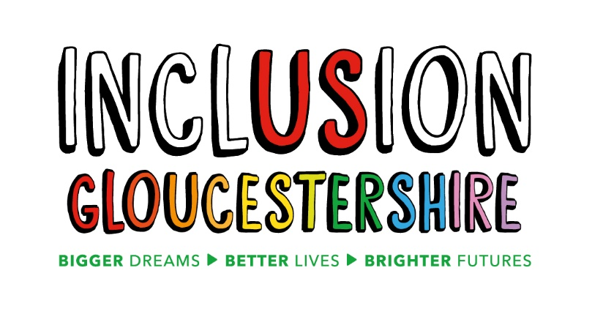
Job Description – Volunteer and Advocacy Project Coordinator
Summary of the Role
This role sits within the Engagement team in an exciting new project, funded by the National Lottery developing Inclusion Gloucestershire’s Volunteer and Advocacy offer. The advocacy and mentoring will be aimed at disabled people and those with autism or mental ill health who are not eligible to access existing services, helping more people to reach their potential and access services by supporting them at the earliest possible stage, reducing isolation and preventing them from reaching crisis point. The team will design and deliver group sessions themed around topics such as employment, housing and independence, as well as individual one-to-one support with individually defined areas of need relating to confidence building, relationships and community access.
The Volunteer and Advocacy Project Coordinator supports the Volunteer and Advocacy Worker and Volunteer and Advocacy Peer Mentor/Experts by Experience (EbE) with lived experience of disability, autism or mental ill health to design and deliver the group sessions and individual support, talking about their experiences and encouraging people to discuss their own concerns, aspirations and wishes.
The coordinator will develop a strong volunteer offer for both people with and without disabilities. They will work with partner organisations to offer a shared volunteer offer if this fits individual need. Some people will volunteer within Inclusion Gloucestershire as an organisation, where we will support them to grow in confidence and develop skills. When people are ready, we can refer them on to other projects such as Forwards or GEM to continue their employment journey.
Job Purpose:
- To support the design and delivery of an advocacy offer, including peer-led sessions to people with disabilities, autism or mental ill health themed around their needs, concerns, aspirations and wishes.
- To support the design and delivery of a volunteer offer targeting both those who can add capacity to the organisation and also those who wish to volunteer with us to develop confidence and skills.
Reports to: Engagement Manager
Main Duties and Responsibilities
- With the Engagement Manager, lead on the design and development of Volunteer and Advocacy offers for Inclusion Gloucestershire. This includes a referral process, needs assessment, recruitment strategy and process, volunteer support and other aspects that link with other areas of the organisation’s offer.
- Develop and deliver inclusive accessible training for the Volunteer and Advocacy project worker and Volunteer Advocacy Peer Mentor/EbE to support those who need an advocate or want to volunteer.
- Develop a volunteer pool of both disabled and non-disabled volunteers
- Support the Volunteer and Advocacy Project Worker and Volunteer and Advocacy Peer Mentor/ EbE to design and deliver group sessions around topics such as employment, housing and independence, confidence building, relationships and community access. At these sessions encourage people to share their experiences and any issues or concerns that they have. Deliver positive messages about the possibilities for disabled adults.
- Support the Volunteer and Advocacy Project Worker and Volunteer and Advocacy Peer Mentor/EbE to design and deliver individual support focused on gaining specific feedback from people about their worries, hopes and ambitions.
- Support the Volunteer and Advocacy Project Worker and Volunteer and Advocacy Peer Mentor/EbE to develop a toolkit of resources, information and organisations that they can draw upon and signpost to
- Support the Volunteer and Advocacy Project Worker and Volunteer and Advocacy Peer Mentor/ EbE to develop their skills and confidence in their roles. This will include providing formal meetings for support and appraisal, approving expenses etc and managing absence in line with Inclusion Gloucestershire procedures
- Carry out a range of tasks to support monitoring and evaluation, including collecting evaluation data, data entry, analysis, reporting and review
- Prepare written reports as required including to demonstrate the impact of the Volunteer and Advocacy offer for individuals, co producing these with others
- Present information in an appropriate and accessible format when needed
- Work effectively with the team and partner organisations keeping them informed of progress and issues as well as working cooperatively and ensuring the quality of stakeholder relationships is second to none.
- Help to keep participants and staff safe and confident in their surroundings and act on safeguarding and health and safety concerns in line with Inclusion Gloucestershire’s policies.
- Advocate for Inclusion Gloucestershire and its projects at meetings and events and within your own appropriate networks.
- Help foster a positive, supportive team culture for staff and participants alike and work in line with Inclusion Gloucestershire’s principles of being inclusive and user-led.
- Complete appropriate training
- Any other duties as reasonably required.

This role profile is not exhaustive and may be subject to change to meet the operational needs of the organisation.
Essential Skills/Experience
- Experience of supporting or working with people with disabilities, mental ill health or autism.
- Understand the social model of disability.
- Able to coordinate a range of people with varied skills and experience.
- Able to plan, manage workload, prioritise tasks and meet deadlines and support others to do so.
- Confident running activities alone and able to work without supervision.
- Positive, resilient, calm and able to use initiative.
- Able to keep clear notes and reflect on and analyse feedback, reviewing for themes.
- Competent in IT and good standard of written English including creating presentations and writing reports and good numeracy skills.
- Excellent communication skills and ability to easily build rapport with individuals, staff, managers and partners.
- Ability to show empathy and active listening skills.
- Trustworthy and able to handle and manage confidential information.
- Reliable.
- Able to be a proactive team player.
- Ability to work without supervision.
- Willing to learn and open to new opportunities.
- Friendly, caring and understanding.
- Understanding of safeguarding and health and safety (training will be provided)
- Able to travel throughout the county.
- Able to work flexibly with some evening and weekend work.
- Willing to learn and open to new opportunities.

Desirable Skills/Experience
- Experience of working with volunteers and or advocates.
- Experience of developing and training others.
- Line management or supervisory experience.
Values and Personal Beliefs
Inclusion Gloucestershire is driven by its values, at the heart of all that it does. Teams are expected to share and demonstrate these values:
- Make sure everyone is involved and included.
- Empower choice and control through peer support and place experts by experience at the centre of our delivery.
- Challenge when things aren’t right and give people with disabilities a strong voice.
- Treat people fairly and always behave in a way that is honest and trustworthy even when nobody is looking.
- Be a caring and professional organisation who work together towards shared goals.
- Work together to deliver exciting new ideas and support each other, our members and our community.

