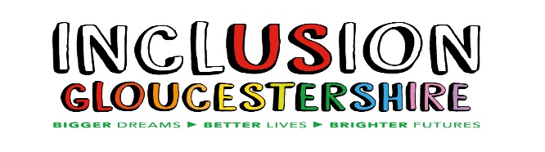
We are looking for an
Inclusion Hubs Coordinator
to join our friendly and inclusive team!

Summary of the Role
Inclusion Gloucestershire is a Disabled People’s Organisation. Our vision is to help achieve an inclusive society that values, respects and includes disabled people every day and in every way.
We are looking for a Project Coordinator to join our Cheltenham Hub and provide some cover support for our other hubs in Gloucester and the Forest of Dean.
This role sits within the Inclusion Hub team, alongside other Inclusion Hubs Coordinators, Project Workers and the Inclusion Hubs Manager. We are committed to the Inclusion hubs being peer-led, meaning that a project worker who has lived experience of a disability, autism or mental ill health will support us to make sure the Inclusion hubs are run by the people it supports.
Your role will be to coordinate the delivery the Cheltenham Hub and to deliver the Hub on alternate weeks alongside our partners. The focus should be on reducing social isolation and supporting people to have their voices heard, while increasing knowledge by offering advice, support, activities, information, and education opportunities.

Hours and pay:

Hours: 6 hours per week, to be worked over a Wednesday and Thursday.
(Cheltenham hub runs on alternate Thursdays from 12.30pm-3.30pm. Gloucester and Forest of Dean hubs run on Wednesdays from between 10 and 2.)

Contract: Permanent – subject to contract.

Pension: IG operates the NEST pension scheme and will contribute 3% subject to qualifying status.

Salary: £16.08 per hour.

Locations: Core hours to be worked at:
Cheltenham Hub: Oasis Centre, Cassin Drive, Cheltenham

Occasional hours to be worked at:
Gloucester Hub: Friends Meeting House, Greyfriars, Gloucester,
Forest Hub: Salvation Army, 43 North Road, Broadwell.
Women’s Wellbeing: Friendship Café, Chequers, Painswick Road

Holiday: 28 days + Bank Holidays (pro rata)

Closing date for completed applications: 5pm on Friday 20th of February 2026

We are proud to have been recognised with an Inclusive Employer award but realise that people from some backgrounds are under-represented in our workforce and across the wider charity sector. A more diverse workforce will enable us to deliver even more impact, and we particularly encourage applications from communities which are currently underrepresented. This includes people from ethnically diverse communities, people with lived experience of disability or mental ill health, and people who are neurodivergent.

Applications that are entirely generated by artificial intelligence will not be shortlisted, please ensure that you are referencing your own experience.

For individuals wanting more information or to request a Job Pack, please email info@inclusion-glos.org or phone 01452 234003. Alternatively, all documents can be downloaded from our website https://www.inclusiongloucestershire.co.uk/jobs/
Please let us know if you need these documents in another format.

Shortlisting: Week commencing 23rd of February 2026

Intended Interview date: Week commencing 23rd of February 2026

Charity Number – 1171559
An application form will be included in the Job Pack. We do not accept CVs without an application form.
This role isn’t funded by National Lottery funds or any other funds raised through the proceeds of a lottery, gambling or through interest or investments

