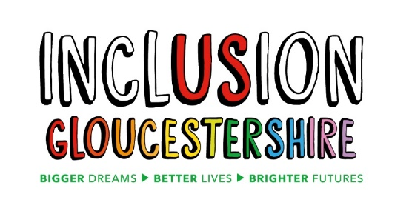

We are looking for a team of
Experts by Experience - Community Mental Health Transformation
8 posts
Inclusion Gloucestershire is a growing, dynamic user-led organisation, run by disabled people and those with mental ill health. We are passionate, person-centred, inclusive and have a track record of high-quality delivery.

As an expert by experience, you will represent your own views and those of others with lived experience of mental ill health in the development of support and services in the community. Such support will be delivered in ways that are personalised and holistic and ensure that people with mental ill health get the right support at the right time.
As part of Community Mental Health Transformation, people with lived experience alongside voluntary and community organisations will co-produce with the NHS and Local Authority (Council) to support a joined-up approach to support people’s mental health and wellbeing needs.

We would like our team to have a variety of lived experiences and for this reason we would particularly welcome applications from people who:

- Are aged 65+
- Are of working age (18+)
- Are younger and have experience of moving to adults services(18-25 yrs)
- Have lived experience of complex trauma related needs
- Have lived experience of other complexities (drug and alcohol misuse, homelessness, involvement in criminal justice system)
- Have lived experience of eating disorder
- Have lived experience of serious mental illness such as schizophrenia or other psychotic disorders
- Have lived experience as a family carer of someone with mental ill health
- Are from a BAME community

Job Purpose: To represent lived experience to transform health, care and support for people with mental ill health needs. The aim of the transformation of community health services is to deliver an integrated service that puts the person right at the centre of their care and improves both experience and quality of service delivery.

Reports to: Community Mental Health Transformation Project Coordinator

Hours and pay:
Hours: This is a zero hours contract although we anticipate approximately 2-4 half days work per month

Contract: Fixed term to 31.3.22 with possible extension for a further 2 years

Salary: £50 per half day (up to 4 hours) which includes paid annual leave and funding towards travel costs and provision of own IT equipment and internet access

This post will be based at home with some attendance at our office and other venues as required
Our office is based at 2 St Michaels Court, St Michaels Square, Gloucester, GL1 1JB

As restrictions on social interaction are lifted over forthcoming months, applicants should be prepared to work in face to face settings when safe to do so

For individuals wanting more information on any of these jobs please download our Job Descriptions and Application form from our website
https://www.inclusiongloucestershire.co.uk/jobs/
You can also request a job pack by phone (01452 234003).

If you would like an informal discussion about any of the roles, please email dawnc@inclusion-glos.org and she will give you a call
There will also be two open group discussion sessions on Zoom where you can come along and ask questions about the roles.
These will be held on:
Tuesday 11th May 6.00 pm-7.00pm
Thursday 20th May 10.30am -11.30pm
If you would like to attend either of these sessions, please email dawnc@inclusion-glos.org or call Dawn on 07525847383 and she will let you know the Zoom link
You do NOT need to come to the Zoom sessions unless you want to
Closing date for completed applications: Midnight on Tuesday 25th May
Intended Interview Dates: 2nd and 4th June 2021
N.B Interviews will be held via video call – instructions will be provided on how to set this up)

Charity Number – 1171559

