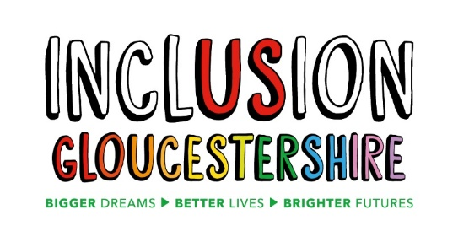

We are looking for a
Community Mental Health Transformation Project Coordinator
Inclusion Gloucestershire is a growing, dynamic user-led organisation, run by disabled people for disabled people. We are passionate, person-centred, inclusive and have a track record of high-quality delivery.

This role coordinates the active and meaningful involvement of people with lived experience of mental ill health in the redesign of community mental health supports and services in Gloucestershire.

Job Purpose: To engage, recruit and support people with lived experience of mental ill health to have an active role in the transformation of treatment and support for people with mental ill health needs.

To facilitate participation of Experts by Experience in a co-production group and other forums as an integral part of Community Mental Health Transformation in Gloucestershire.
Reports to: Director of Research, Strategy and Partnerships/Engagement Manager (To be confirmed)
Hours and pay:
Hours: 7.5 - 10 hours per week (exact hours to be confirmed)

Contract: Fixed term to 31.3.24

Pension: IG operates the NEST pension scheme and will contribute 3% subject to qualifying status

Salary: £4480 - £5973 (£22 401 pro rata)
N.B. This post may be combined with the 11hour MHELO Coordinator Post that is also being advertised. If you wish to apply for both posts, please indicate this on your application form.
This post will be based at
2 St Michaels Court, St Michaels Square, Gloucester, GL1 1JB and all posts have a holiday entitlement of 28 days + bank holidays pro rata

(Some home working may apply due to COVID-19 but staff should be prepared to work in face to face settings when safe to do so)

For individuals wanting more information on any of these jobs please download our Job Descriptions and Application form from our website
https://www.inclusiongloucestershire.co.uk/jobs/
You can also request a job pack by phone (01452 234003).

If you would like an informal discussion about any of the roles, please email dawnc@inclusion-glos.org and she will give you a call

Closing date: Midnight on 12th April
Intended Interview Date: 23rd April
N.B Interviews may be held via video call – instructions will be provided on how to set this up)

Charity Number – 1171559

