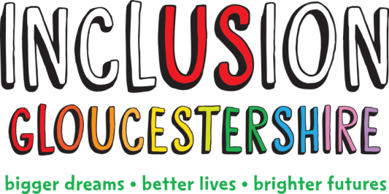

We are looking for an
Expert by Experience to support our Friendship Hub
Inclusion Gloucestershire believes that everyone has gifts, ambitions, aspirations and strengths. Sometimes, people with disabilities or mental ill health experience barriers, setbacks and challenges which hinder their personal potential.
We have an exciting opportunity to join our team, working in partnership with the Friendship Café to support running the Friendship Hub- a women only group, engaging with BAME communities to offer advice, support, activities, information and consultation opportunities.
Summary of the Role
This job is helping to run an Inclusion Hub for one day a week from the Friendship Café in Gloucester. It is for people from Black, Asian and minority ethnic (BAME) communities with disabilities. The Hub will offer opportunities for people to have their say, talks on healthy living, information, support and activities.
This project is important because people from BAME communities are more likely to have poorer health and not be as well supported as other people.
This role sits within the Engagement team, alongside Project Coordinator, Project Worker and the Engagement Manager
You will have lived experience of disability (physical, learning or mental ill health) and will be an expert in making sure people are included. You will work with a colleague who has experience of getting people from many different backgrounds involved.
Job Purpose: To be a visible peer lead at the Friendship Hub, making it a welcoming safe space.
Hours and pay:
Weekly hours: 4 hours per week
Contract: Fixed term until 31.04.22
Pension: IG operates the NEST pension scheme and will contribute 3% subject to qualifying status

Salary: £17,374.50 (£1,853.28 pro rata)
Location: The Friendship Café, Chequers Bridge, Painswick Road, Gloucester, GL4 6PR
Holiday: 28 days + bank holidays
Appointment to this role requires an Enhanced DBS check
Due to the nature of the work carried out in the Friendship Hub this role is restricted to female applicants only in accordance with the provisions of the occupational requirement (Equality Act 2010, pursuant to Schedule 9, Part 1).
For individuals wanting more information on any of these jobs please download our Job Descriptions and Application form from our website. CVs alone will not be accepted.
You can also request a job pack by phone (01452 234003).
If you would like an informal discussion about the roles, please email jow@inclusion-glos.org and she will give you a call
Closing date: 19th of November
Intended Interview Date: 26th of November or the 2nd of December
N.B Interviews may be held via video call – instructions will be provided on how to set this up)
Charity Number – 1171559

