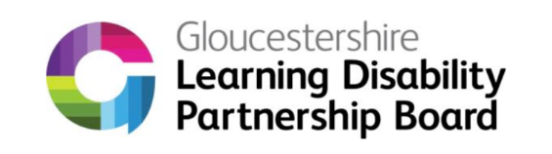
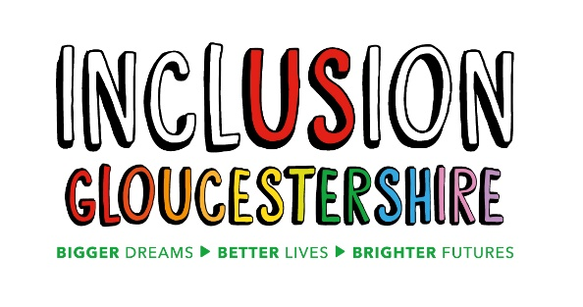

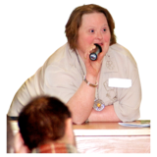 | We are looking for a new Co-Chair for the Learning Disability Partnership Board
 | The Learning Disability Partnership Board brings together different people who want to make things better for people with a Learning Disability
    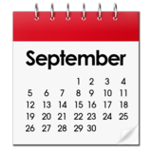 | The board meets every 2 months
 | We need someone who can work 4 hours every week
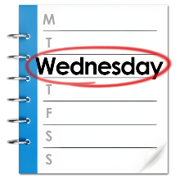  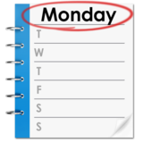 | Most work will be on a Monday morning and a Wednesday afternoon
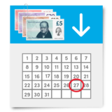 | The pay is £13.78 per hour
 | There would be time off for holiday
   | If you want help to apply for the job, please call us on:  01452 234003 or  email: info@inclusion-glos.org
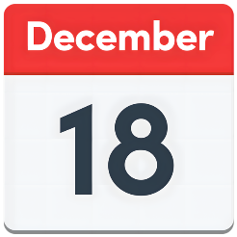  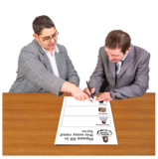 | You need to tell us you are interested in the job by the 18th of December
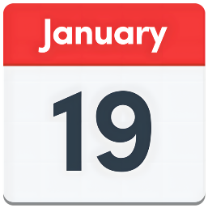  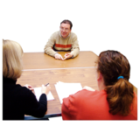 | There will be an interview in Gloucester on the 19th of January 2026  We will try to make it friendly and relaxed
 | You can tell us what will make the interview work best for you.

