

Partnership Board Co-Chair
(Expert by Experience)

What is the job?
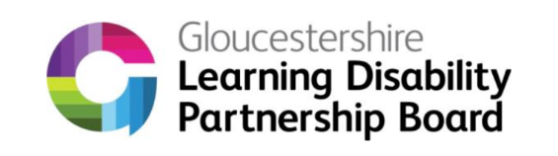 | We need a new co-chair for the Learning Disability Partnership Board in Gloucestershire.
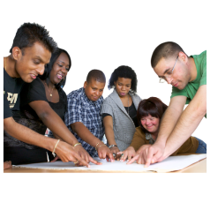 | The Partnership Board is a group of people trying to make things better for people with a Learning Disability.
     | The Partnership Board meets every 2 months.
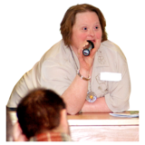 | The co-chair helps run the meetings.
   | The co-chair will go to other meetings about health and transport.
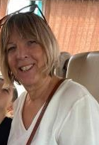 | The co-chair will work together with another co-chair, Jan Marriott.
 | The co-chair will speak up about what people with a Learning Disability say needs to change.

Who will support me?
  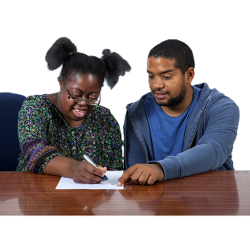 | Paul is the project co-ordinator.  He will be the co-chair’s line manager.

What do you have to do with this job?
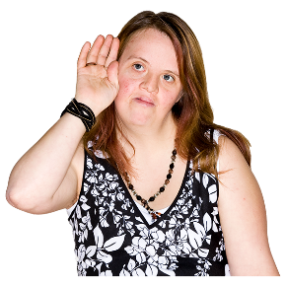 | You will listen to people
 | You will speak up about what other people think about things
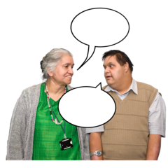 | You will tell people what you think about things
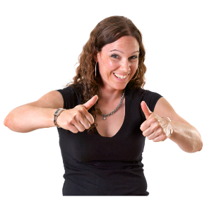 | You will tell people about the partnership board and Inclusion Gloucestershire
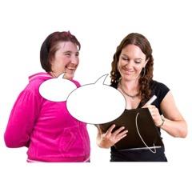 | Sometimes we might ask you to do other things  This might be going to a meeting, or helping to do a presentation

What do you need to be able to do?
We use the highlighted ones to help us decide who to interview.

Please show us in your application that you have these skills or experiences.

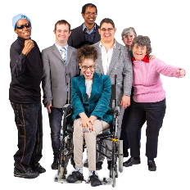 | You need to be a person with a learning disability
 | You need to talk in front of lots of people
 | You need to be able to listen to other people
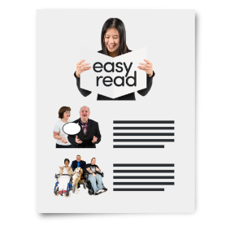 | You need to be able to read a little bit – so you can read something that is in Easy Read.
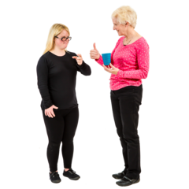 | You need to know how to talk to different people
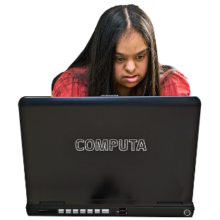 | You need to take part in online meetings
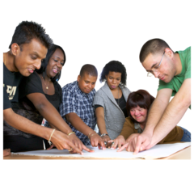 | You need to work well with others
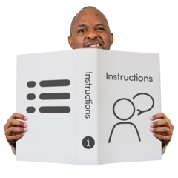 | You need to be able to follow instructions
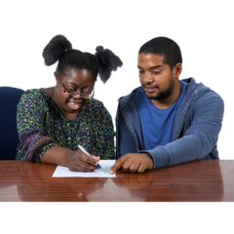 | You should be happy to learn new things
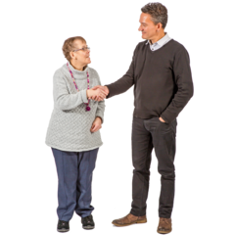 | You need to be friendly, caring and honest
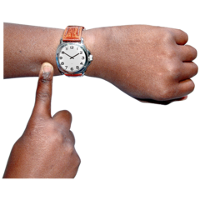 | You need to be on time, and turn up when you say you will

It would be good if you already know about:
The Learning Disability Partnership Board

Let us know if you would like to come along to our next meeting to find out more

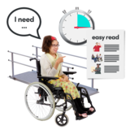 | Some of the problems that people with a Learning Disability can have
  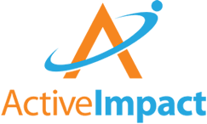  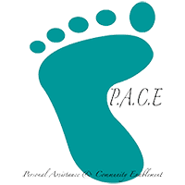   | The different organisations helping people in Gloucestershire

Inclusion Gloucestershire believes that all staff should:
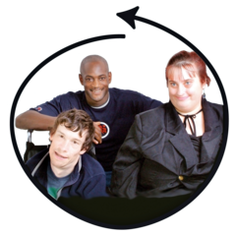 | Make sure everyone is included
 | Make sure experts by experience have choice and control at work
 | Stand up for disabled people when things aren’t right
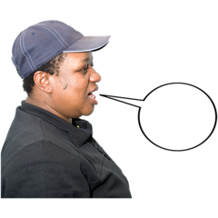 | Be fair and honest all the time
 | Be caring and professional
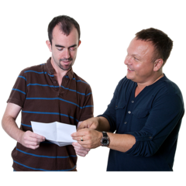 | Support each other to do exciting new things

