Inclusion Gloucestershire Newsletter

Item 1:

A message from Deputy CEO/ Operations Director; Ailsa Lane:

Welcome to our June Newsletter. Following a recent restructure within our Senior Leadership Team, I am delighted to have taken up the role of Deputy CEO and Director of Operations. I’ve worked for the organisation for 10 years, as part of Inclusion Gloucestershire’s Senior Leadership Team since 2018 and prior to that with Gloucestershire Voices managing our Drama and Training projects. I’m passionate about inclusion and reducing inequalities and aim to be an ally to those facing disabling barriers.

I love working in partnership with others so if you have an idea for a new project that could remove disabling barriers for people in Gloucestershire do get in touch:

[ailsal@inclusion-glos.org](mailto:ailsal@inclusion-glos.org)

Item 2:

Check out our latest short film!



Image description: The image is a still from the short film entitled Highs and Lows. The image is of Jason (played by Nick) wearing a red cap and Harry Potter costume. He has a white beard and a serious expression. There is dark green foliage in the background.

Highs and Lows is a film about relationships and friendships, devised and created by the members of Inclusion Gloucestershire's inclusive drama group, Dramatic Change. The film follows different people's stories and how they navigate the highs and lows of friendships and relationships. You can watch it [here](https://www.youtube.com/watch?v=lQoALwwvZkU).

If you are interested in joining one of our Drama groups email [drama@inclusion-glos.org](mailto:drama@inclusion-glos.org). You can also find out more from [www.inclusiongloucestershire.co.uk](http://www.inclusiongloucestershire.co.uk)

Item 3:

National Spotlight on Quality Checking

Gloucestershire’s Expert by Experience led approach to checking the quality of care providers was featured on the Local Government Association website as a successful case study. We are proud to lead the way on putting people with lived experience at the heart of making sure people are receiving the best possible care and support.

“Inclusion Gloucestershire’s Quality Checking service plays a vital role in assessing and improving the quality of care for individuals who receive support commissioned by Gloucestershire”

Read the case study here – [Inclusion Gloucestershire quality checking experts by experience | Local Government Association](https://www.local.gov.uk/case-studies/inclusion-gloucestershire-quality-checking-experts-experience)

Item 4:

Scam Emails

Inclusion Gloucestershire staff and volunteers will never ask you to buy something on their behalf. If this happens, please share the email immediately with [info@inclusion-glos.org](mailto:info@inclusion-glos.org), or forward it to [report@phishing.gov.uk](mailto:report@phishing.gov.uk).

Signs of a possible [phishing](https://www.phishing.org/what-is-phishing) email:

* The individual starts by saying that they can’t speak on the phone. If this happens you can speak to one of our team at the office by calling 01452 234003
* The individual says that they can’t leave the house or need urgent help to buy something.
* There is no email signature, or it doesn’t look like a usual Inclusion Gloucestershire signature
* Click this [link](https://www.phishing.org/what-is-phishing) for more information about phishing or this [link](https://www.mencap.org.uk/easyread/how-protect-yourself-scams) for Easy Read information

We have extra security and software to keep our email accounts as safe as possible, but we all need to beware of scam emails.

Item 5:

Join Us!

Become a member of Inclusion Gloucestershire:

<https://www.inclusiongloucestershire.co.uk/become-a-member/> or phone 01452 234003

Work with us – check out our latest vacancies: <https://www.inclusiongloucestershire.co.uk/jobs/>

Hover and click on the icons below to:

Follow us on Twitter [Twitter icon](https://twitter.com/InclusionGlos)

Follow us on Facebook [Facebook icon](https://www.facebook.com/inclusionglos)

](https://www.instagram.com/inclusiongloucestershire/?hl=en)

Follow us on Youtube [](https://www.youtube.com/channel/UCPtMb2HMGTpHOt5ijpRiGrA)

Item 6:

University of Gloucestershire Simulation Days

Over the past few weeks some of our Drama Group and Training Team have been attending some Simulation Days. These are days where our team take part in role play activities for students so they can learn how to take care of people with a learning disability and/or autism during social work visits or major incidents. Everyone at the University said how much they enjoyed the day and how fantastic our Actors were.

During one of the events Rachael and Tim played students attending a festival which had gone wrong. Students from the Paramedic Teams, Policing and Nursing all took part in this major incident simulation to practice how to deal with an emergency situation. Both Actors played the part of students who had been injured during the incident and students assessed their injuries and provided treatment and care and Tim and Rachael fed back to the students at the end as to how they had done.

Below are a couple of photos of the event showing Tim in pain with his “injury” and the collapsed stage at the event.

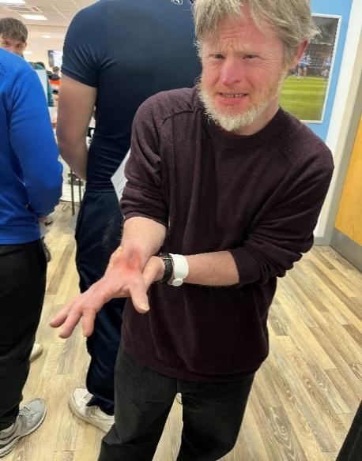

Photo description: Tim is pictured acting, grimacing with pain as he clutches his wrist. He is wearing a brown jumper and has grey-blonde hair and beard.

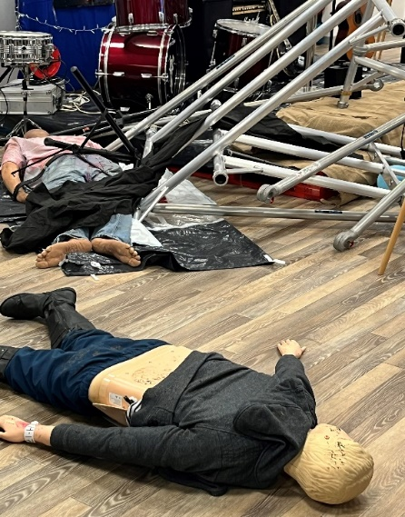

Photo description: Two dummies lie on the floor as if they are casualties. Collapsed scaffolding can be seen in the background.

Item 7:

Upcycling Chairs at the Forest Hub

The forest hub completed our upcycled chair project in collaboration with Wyldwood Arts for the Fringe Festival in the Forest of Dean. The project was a great success and was initially started by Nirvana, securing the funding, venue and kickstarting the plan. We displayed our chairs at Taurus Crafts and this project was a great way to connect the hub to the local forest community, working with a handful of local businesses. Kate Fellows from Wyldwood Arts was a fantastic artist to work with and really helped the chairs come to life. All the members really enjoyed working on the chairs and one member commented on how the project had helped build her confidence, as she could make something others would like to look at and felt more connected to the local community.  Taurus Crafts loved having our chairs displayed at their venue and commented:

“It's been lovely having the chairs in the marquee. The bright colours have made me smile every time I see them, and there's some really nice feedback on the forms alongside them.”

We had a wonderful day out at Taurus Crafts to celebrate having the chairs there, walked around and had lunch which all the members enjoyed. We’re currently looking for a home for the chairs, and there has been some interest, but nothing set in stone yet. If anyone knows of anyone who would be interested, please let the forest hub know.

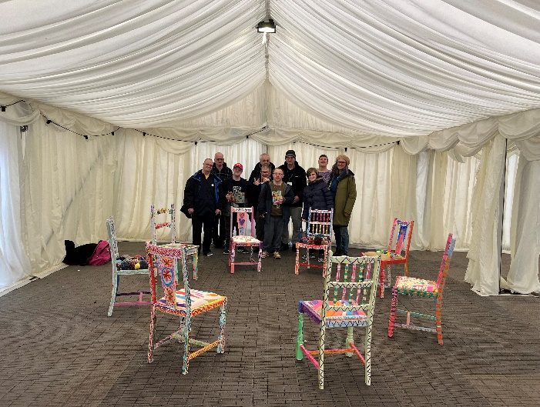

Photo description: Members of the Forest Hub stand at the back of a white marquee tent with painted chairs grouped in a circle in front of them.

Item 8:

Get Involved in Gloucestershire’s new Partnerships Board Webpage

Get Involved in Gloucestershire (part of the NHS in the county) have just published a webpage signposting people to information about Gloucestershire’s six Partnership Boards.

[Gloucestershire Partnership Boards | Get Involved In Gloucestershire (glos.nhs.uk)](https://getinvolved.glos.nhs.uk/gloucestershire-partnership-boards)

Our Partnership Boards bring together people with lived experience as well as lots of professionals from different organisations.

Please share this link with your networks

Thank you!

Item 9:

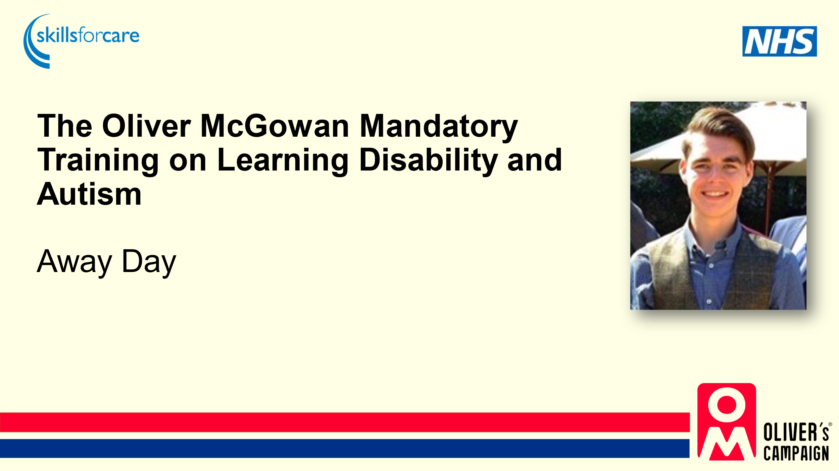

Image description: Writing that says 'The Oliver McGowan Mandatory Training on Learning Disability and Autism Away Day.' A headshot of Oliver McGowan, the red and blue Oliver McGowan mandatory training logo, the blue NHS logo and the blue Skills for care logo.

Recently our team all attended an Away Day. We spent time getting to know one another and what everybody does in the team.

We celebrated all the great work we have been doing and looked at what has gone well and what we have to look forward to in the future.

We also asked everyone to fill in a form telling us what they enjoy about their job. We had some great answers including “a kind and inclusive team” and “having the opportunity to share Oliver’s story with others”.

We asked everyone to tell us what could be better about their job so we can try and improve things in the future for our team.

We all had a great day and it was lovely to see most of the team together sharing their thoughts and experiences with each other.

Well done to everyone involved, we are all doing a great job!

Item 10:

Women’s Wellbeing Hub Celebration Event

On 24th April 2024 the Women’s Wellbeing Hub hosted a celebration event at the Friendship café in Gloucester. The members wanted to celebrate a year of friendship, learning, and increased confidence. They have taken part in sessions and workshops about stress and anxiety and practical ways of coping. The members invited guests to celebrate with them with a view to recruiting a wider membership from other local communities.  Zareen and Sana opened the event with a short introduction, sharing an insight into the Hub, its aims, membership, and the opportunities offered. Suzie from Art Lift provided an insight into the activities they provided and agreed to support the Hub in the Autumn. The highlight of the event was when fifteen members stood together in front of an audience of twenty-nine guests and spoke about how “attending the Hub sessions has improved their mental health”. None of the women had ever spoken in public, and it shows how far they have come. They all spoke with passion, about how they enjoy the sessions and have become stronger. Two of the members did not feel confident enough to speak in English, so they spoke in Gujarati, and Sana interpreted for the audience! The closing activity involved everyone present contributing ideas for future activities. Many of the guests indicated they would like to come along and try the hub.

Item 11:

Office Move

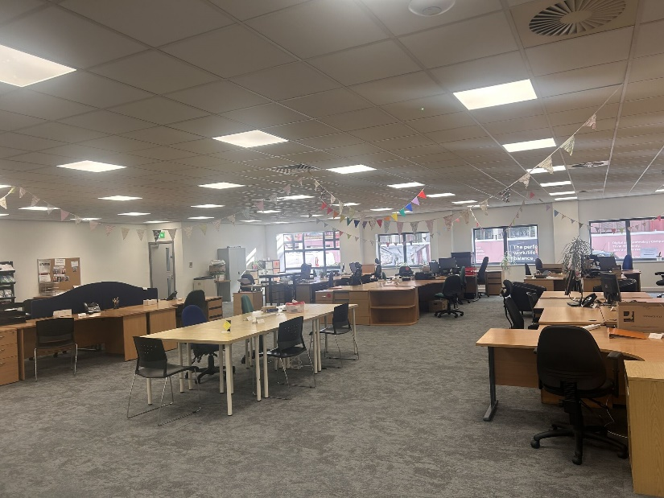

Photo description: an open plan office with lots of desks and chairs, and bunting hanging from the ceiling.

We are delighted to have moved into our permanent home on the ground floor of Railway House, Bruton Way, Gloucester, GL1 1DG. We have been in the building since last October but our ground floor office has only recently been ready to move into. A huge thank you to everyone who helped make it happen!

If you are due to visit Railway House for a meeting but aren’t sure how to find us, you can find out [here](https://www.inclusiongloucestershire.co.uk/how-to-travel-to-the-inclusion-gloucestershire-office-railway-house-2/).

End of newsletter.