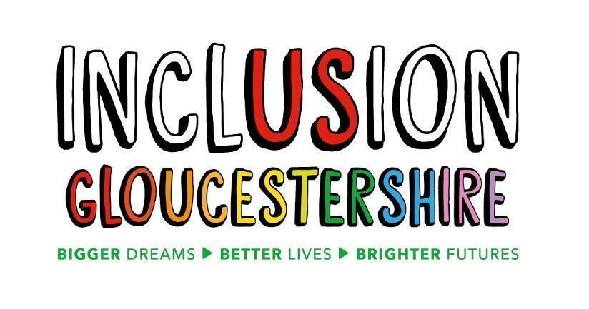
Job Description: Expert by Experience Project Worker and Rethink Forum Participant (MHELO)
Summary of the Role
Project worker:
Inclusion Gloucestershire is a disabled people’s organisation that exists to facilitate inclusion for people who face disabling barriers, every day and in every way.
We are seeking a project worker with lived experience of mental illness for our MHELO project.
MHELO (mental health experience led opportunities) is a network for people with lived experience of mental health. We run engagement activities, consultation sessions and events.
The project worker will work with the coordinator, the chairs and volunteers to plan and deliver peer-led engagement activities to gather the views and experiences of those with lived experience of mental ill health. This will include focus groups, surveys, and community-based events.
Rethink Forum Participant:
Each Forum Participant will represent a locality (or multiple localities, provided that the Forum Participant can demonstrate a good understanding and links to each locality).
Forum Participants will attend the forum meetings, which are run by Rethink. These are run quarterly (every 3 months) in each locality. These are strategic forums thinking about things to change, opportunities for systemic change and better lives for people with serious mental illness (SMI).
Job Purpose:
- As a Project Worker, plan and deliver peer-led engagement activities to gather the views and experiences of those with lived experience of mental ill health in line with the MHELO project plan.
- As a Forum Participant you will contribute thoughts, reflections and ideas that reflect the priorities of people living with mental health needs within your localities. This is to help the mental health system in Gloucestershire to be joined up, identify provision and training gaps and to co-produce solutions to problems.
In between forum meetings, Forum Participants will need to engage with networks to ensure that they understand priorities for people in their locality.
Reports to: Project Coordinator
Main Duties and Responsibilities
- Coproduce, plan and deliver peer-led engagement activities in line with MHELO project plan. This engagement may take the form of speaking with people over the phone, engaging with people online or speaking face to face with people 1 to 1 or in groups.
- Research aspects of mental health services to support the overall outcomes of the project.
- Attend a range of community venues and online forums to engage with people with lived experience.
- Capture accurate notes and/ or record feedback from engagement activities in an agreed format.
- Coproduce reports with findings from engagement activities.
- Work with the MHELO coordinator to make sure that actions are carried out in the time agreed.

- Demonstrate excellent communication skills including active listening.
- Keep sensitive/confidential information to themselves.
- Report safety concerns in line with Inclusion Gloucestershire’s policies.
- Advocate for Inclusion Gloucestershire and it’s projects at meetings and events and within your own appropriate networks.
- Help foster a positive, supportive team culture for staff and participants, and work in line with Inclusion Gloucestershire’s principles of being inclusive and user-led.
- Help to keep members and staff safe and confident in their surroundings and act on safeguarding and health and safety concerns in line with Inclusion Gloucestershire’s policies.

- Advocate for MHELO and Inclusion Gloucestershire and its projects at meetings and events and within your own appropriate networks.

This role may require some evening and weekend work
This role profile is not exhaustive and may be subject to change to meet the operational needs of the organisation.
Required skills and characteristics
N.B. Those items marked * will be used as shortlisting criteria for this post
Job specific requirements
- Lived experience of mental ill health and mental health services in a personal capacity
- Understanding of the needs of people with mental health needs and their carers
- Able to represent a range of communities not just your own and present these to others.
- Commitment to collaborative working including appreciating different perspectives and being focussed on solutions and constructive in approach.
- Confident and clear communicator with good verbal and written communication skills.
- Trustworthy and able to handle confidential information
- Good IT skills
- Able to enable emotionally safe environments and build rapport with people
- Positive, enthusiastic and able to lead by example
- Able to travel independently to and from the Inclusion Gloucestershire Office and to other locations.
Desirable Skills/Experience
- Experience of leading group discussions
- Experience of lived experience research: (carrying out interviews/focus groups using paper-based tools and in person and collation and evaluation)

Values and Personal Beliefs
Inclusion Gloucestershire is driven by its values, at the heart of all that it does. Teams are expected to share and demonstrate these values:
- We are a user-led organisation, driven by the social model of disability, which sees people as disabled by society rather than by their impairment or difference.
- We make sure everyone is meaningfully involved and included
- We empower choice and control through peer leads and place experts by experience at the forefront of our delivery
- We challenge when things aren’t right and give people facing disabling barriers a strong voice
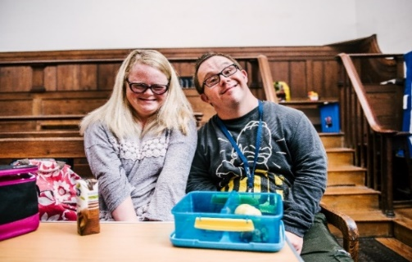
- We believe it is right to treat people fairly and always behave in a way that is honest and trustworthy even when nobody is looking
- We are a caring and professional organisation who work together towards shared goals
- We work in partnership to deliver exciting new ideas and support each other, our members and our community.

Charity Number – 1171559
This role isn’t funded by National Lottery funds or any other funds raised through the proceeds of a lottery, gambling or through interest or investments

