


 | We are looking for people to be Travel trainers.
 | A Travel Trainer is a person with a disability who can use public transport to travel on their own.
 | They help other people with disabilities to become more confident at travelling
 | Travel trainers work as part of a team with a project  Co-ordinator and three project workers
 | Hours are flexible, but it is likely that there will be at least 1-5 hours per week
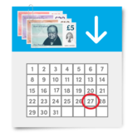 | The pay is £12.79 per hour.
   | If you want help to apply for the job, please call us on:  01452 234003 or  email: info@inclusion-glos.org
 | You need to tell us you are interested in the job by filling in an application form.
 | You will have an interview.  This will be with the co-ordinator and project worker.  We will try to make it friendly and relaxed.
 | You can tell us what will make the interview work best for you.

