

Travel Trainer

What is the job?
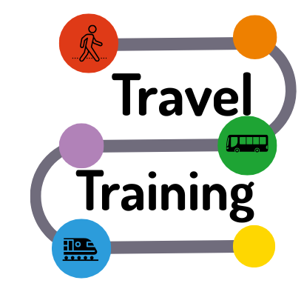 | We are looking for people to be Travel trainers.
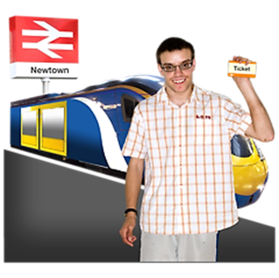 | A Travel Trainer is a person with a disability who can use public transport to travel on their own.
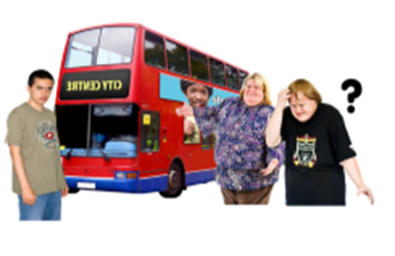 | They help other people with disabilities to become more confident at travelling.
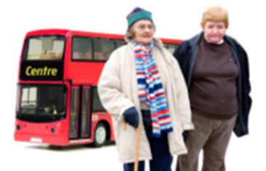 | You will support people to take the bus or train.
  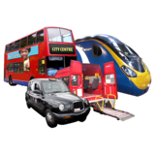 | You will need to be confident and safe when travelling on your own
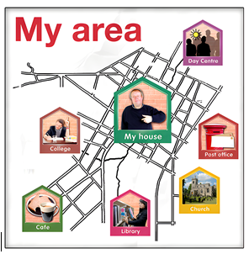 | You should be willing to travel out of your home area and around Gloucestershire.

Who will support me?
  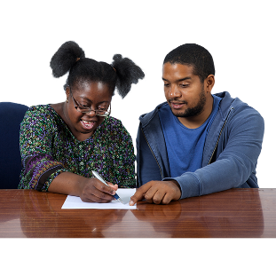 | Olivia is the project co-ordinator.  She will be the Travel Trainers line manager.

What do you have to do with this job?
 | The trainer is paired with a trainee. The coordinator or one of the project workers introduces them and joins them for their first few trips.
 | The trainer works with the trainee until they are confident travelling on their own.

What do you need to be able to do?
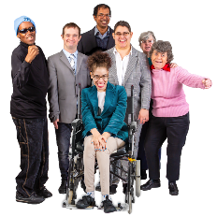 | You need to be a person with a disability and over 18 years old
 | You will need to be kind to travel trainees who may be nervous.
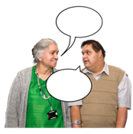 | You will need to be good at communicating with your travel trainee.
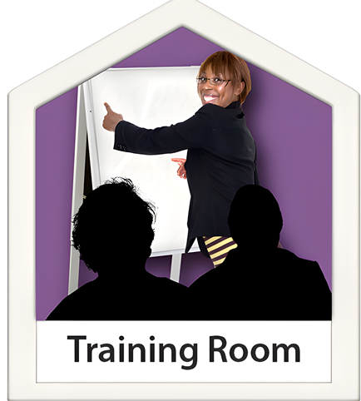 | You should be able to attend different meetings and training days
 | You should be willing to listen, learn and follow instructions
 | You need to work well with others
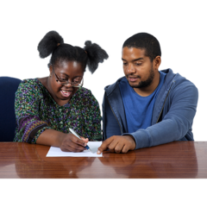 | You should be happy to learn new things
 | You need to be friendly and caring
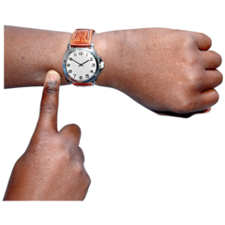 | You need to be on time, and turn up when you say you will.

You will have training:
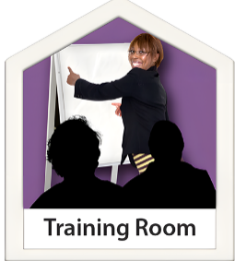  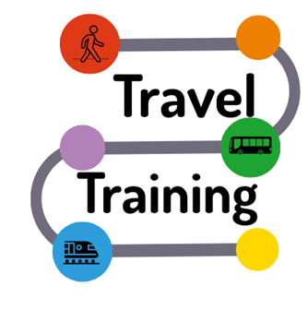 | Travel Trainers will need to have training, so they know how to help others.  This training will help you to:
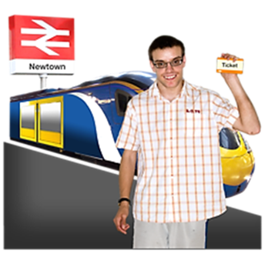 | Understand your role.
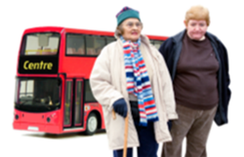 | Learn how to support someone to travel on their own.
 | Learn how to stay safe when travel training

Inclusion Gloucestershire believes that all staff should:

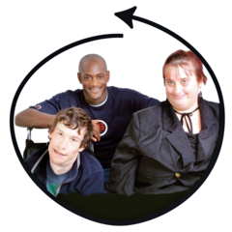 | Make sure everyone is included
 | Make sure experts by experience have choice and control at work
 | Stand up for disabled people when things aren’t right
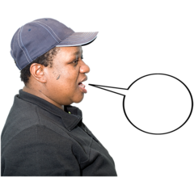 | Be fair and honest all the time
 | Be caring and professional
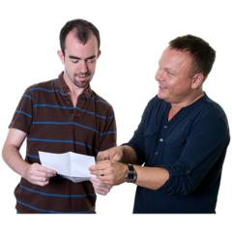 | Support each other to do exciting new things

