Travel Training/Companion Journeys

What is the difference?
Companion   | You do not plan to take a bus or train on your own.  Or you want to see what it is like having someone support you to take a bus or train before referring to travel training
Travel Training  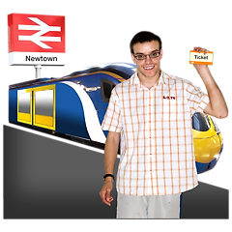 | You want to learn how to take the bus or train on your own

How the Travel Training scheme works:

 | You fill out the form to get travel training or companion journey

Travel Training
 | 
 | 
Initial meeting  The coordinator or the project worker meets you to discuss travel training and what you need | Meet your trainer  You are paired with a trainer. The coordinator or one of the project workers introduces them and you fill out a form.
 |   
Training sessions  The trainer works with the you until you are confident travelling on your own. | Success!!  You can do the journey on your own. Observed by a project worker that you can travel independent.

 | You will get a certificate for Travel Training

Companion Journey

Initial meeting  The coordinator or the project worker talks to you about your journey | Meet your trainer  You are paired with a trainer. The coordinator or one of the project workers introduces them and you fill out a form.
You do your journey together | Success!!  You have completed your journey

