

We are looking for Trustees to join our Board
Who we are
Inclusion Gloucestershire is a Disabled People’s Organisation and registered charity (charity number 1171559). We are run by disabled people for disabled people. We include everyone, and are an exciting organisation to be a part of!
We are looking for trustees to work together to make big decisions for the charity. More information about what trustees do is on the next page, under ‘Trustee Duties’.
About being a Trustee
Trustees need to come to Board meetings every other month on a Wednesday between 5:30pm and 7:30pm, and take part in discussions. They need to prepare for Board meetings by understanding the papers (these can be shared in different ways like Easy Read or video).
There is often an extra optional meeting between board meetings, in which we discuss an issue in more detail or learn about something.
Meetings are a mixture of in person (at our Gloucester office), online by video call, or hybrid (some people online and some people in the room).
Trustees may also help in other ways, like being part of a working group about a particular issue (like HR or marketing).
Trustees need to make important decisions, and find out enough to feel confident to make those decisions.
Trustees speak with each other and the Chief Executive Officer between meetings. We use WhatsApp, phone or email for this.
Commitment
3-4 hours per month in meetings, calls, discussions and board meeting preparation.
Expenses and access
We will pay reasonable travel and access costs to attend meetings.
Who can be a trustee
At Inclusion Gloucestershire you must be aged 18+ to be a trustee.
People who are not disqualified. You can read more about this here.
To manage conflicts of interest, trustees cannot also be employed by the charity, or have been employed by us in the previous 12 months.
A trustee needs to
- Be good at listening and speaking with others
- Be patient and understanding
- Be proud of the work that they do
- Work well in a team
- Want to work hard to help Inclusion Gloucestershire
- Believe in Inclusion Gloucestershire and what we stand for
Who we are looking for
We are ideally looking for people with one or more of these things:
- People with a learning disability
- People with a physical disability or sensory impairment
- People who are neurodivergent
- People with mental ill health
- People with another disability
- People with finance skills and experience
We want the work of our Board to be as accessible and inclusive as possible. We can share information (including board papers) in different ways, like Easy Read or video updates. Please let us know if there are any reasonable adjustments we can make for you.
How to apply
- Fill in an application form (we can do this with you over the phone if helpful, or you can submit it as a video or audio recording)
- We will then invite people to a ‘getting to know you’ interview with 2-3 trustees and the CEO
- People who do well at both of these stages will join the Board at the AGM on Wednesday 4th February 2026
If you have questions, please email info@inclusion-glos.org or phone 01452 234003. To find out more about Inclusion Gloucestershire, please visit our web site at https://www.inclusiongloucestershire.co.uk/
Deadline for applications: midnight Sunday 30th November 2025
Getting to know you interviews: week beginning 8th December 2025 (we will have slots in the early evening)

Trustee Duties
 | Introduction  Being a trustee is an important role.  In the eyes of the law, trustees are the people who must make sure that the charity is working in the right way.  This document explains what trustees must do.
 | Public benefit  Trustees must make sure that the charity is working for the good of the people that it wants to support.  Trustees must understand the charity’s aims and make sure that the work the charity does meets those aims.  These aims (also known as ‘objects’) are written in the Governing Document.  Example: we exist to make life better for people with disabilities. Trustees shouldn’t allow the charity to spend money on a project that helps stray cats, but not people with disabilities.
 | Work according to the Governing Document and the law  The Governing Document sets out all the rules that the charity must work by.  Trustees need to make sure that the charity is working in a way that fits with these rules.  They must also make sure that the charity follows charity law. This might mean getting specialist advice from a solicitor or other expert when needed.  Example: there are laws like the Charities Act (2011) that trustees must make sure we follow.
 | Act in the charity’s best interests  Everything that trustees do must be for the good of the charity.  Trustees must carefully think about their decisions to make sure that they are best for the charity, both now and in the future.  Trustees shouldn’t make decisions that are good for them as a person, but not good for the charity.  Example: trustees shouldn’t decide to spend lots of the charity’s money on a party just for trustees!
 | Manage the charity’s money and belongings well  Trustees must make sure that the charity spends its money wisely  They must make sure that the charity’s money and belongings are used to achieve its aims.  They must make sure that the charity is not at risk of fraud, theft, losing money or borrowing more than it can pay back.  Example: trustees look at and approve the charity’s budget to make sure that the charity isn’t spending more money than it has, or on things that it shouldn’t.
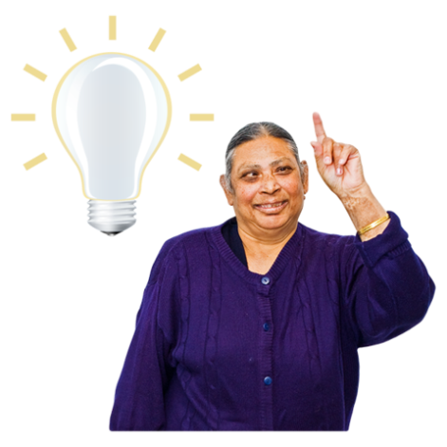 | Act with care and skill  Trustees have very important skills and experience that they should use.  They should also give enough time and energy to being a trustee.  Trustees should ask for advice when they need it.  Example: trustees should come to meetings prepared, with the information and papers that they need. Trustees should speak up and ask questions in meetings.
 | Make sure the charity is well run  Trustees make sure that the charity is producing reports and accounts to prove that it is well run and following the law.  They make sure that members and people who give us money know what we do.  Trustees make sure that staff and volunteers are running the charity well.  Example: we need to send documents and accounts to the Charity Commission and Companies House each year. Trustees should make sure this happens.

