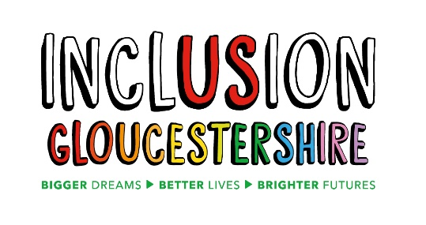
We are looking for an
Volunteer and Advocacy Coordinator
Inclusion Gloucestershire is a growing, dynamic user-led organisation, run by disabled people for disabled people. We are passionate, person-centred, inclusive and have a track record of high-quality delivery.

We have an exciting opportunity to join our expanding talented team as a Volunteer and Advocacy Coordinator, developing and coordinating our new Volunteer and Advocacy offer for individuals with disability, autism and/or mental ill health from across Gloucestershire.
Job Purpose:
- To support the design and delivery of an advocacy offer, including peer-led sessions to people with disabilities, autism or mental ill health themed around their needs, concerns, aspirations and wishes.
- To support the design and delivery of a volunteer offer targeting both those who can add capacity to the organisation and those who wish to volunteer with us to develop confidence and skills.

Reports to: Engagement Manager
Hours and pay:
Hours: 18 per week

Contract: Fixed term until 31.05.23

Pension: IG operates the NEST pension scheme and will contribute 3% subject to qualifying status

Salary: £10,752 (£22401 pro rata)
This post will be based at
2 St Michaels Court, St Michaels Square, Gloucester, GL1 1JB

All posts have a holiday entitlement of 28 days + bank holidays pro rata

(Some home working may apply due to COVID-19 but staff should be prepared to work in face-to-face settings when safe to do so)

For individuals wanting more information on any of these jobs please download our Job Descriptions and Application form from our website
https://www.inclusiongloucestershire.co.uk/jobs/
You can also request a job pack by phone (01452 234003).
If you would like an informal discussion about the role, please email jow@inclusion-glos.org and she will give you a call.
Closing date: Midnight on 16th May
Intended Interview Date: 25th May
N.B Interviews may be held via video call – instructions will be provided on how to set this up)
Charity Number – 1171559

